Nitrogen in Plants
Healthy plants often contain 3 to 4 percent nitrogen in their above-ground tissues. This is a much higher concentration compared to other nutrients. Carbon, hydrogen and oxygen, nutrients that don’t play a significant role in most soil fertility management programs, are the only other nutrients present in higher concentrations.
Nitrogen is so vital because it is a major component of chlorophyll, the compound by which plants use sunlight energy to produce sugars from water and carbon dioxide (i.e., photosynthesis). It is also a major component of amino acids, the building blocks of proteins. Without proteins, plants wither and die. Some proteins act as structural units in plant cells while others act as enzymes, making possible many of the biochemical reactions on which life is based. Nitrogen is a component of energy-transfer compounds, such as ATP (adenosine triphosphate). ATP allows cells to conserve and use the energy released in metabolism. Finally, nitrogen is a significant component of nucleic acids such as DNA, the genetic material that allows cells (and eventually whole plants) to grow and reproduce. Without nitrogen, there would be no life as we know it.

Structure of an Amino Acid
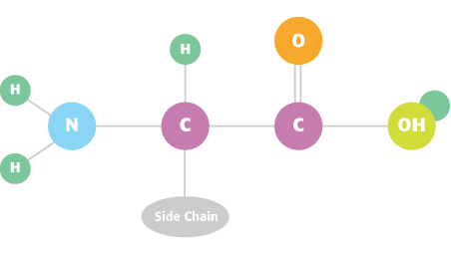Nitrogen is essential for crops to achieve optimum yields. A critical component of amino acids in protein, it also increases protein content of plants directly.

Soil Nitrogen
Soil nitrogen exists in three general forms: organic nitrogen compounds, ammonium (NH₄⁺) ions and nitrate (NO₃⁻) ions.
At any given time, 95 to 99 percent of the potentially available nitrogen in the soil is in organic forms, either in plant and animal residues, in the relatively stable soil organic matter, or in living soil organisms, mainly microbes such as bacteria. This nitrogen is not directly available to plants, but some can be converted to available forms by microorganisms. A very small amount of organic nitrogen may exist in soluble organic compounds, such as urea, that may be slightly available to plants.
The majority of plant-available nitrogen is in the inorganic forms NH₄⁺ and NO₃⁻ (sometimes called mineral nitrogen). Ammonium ions bind to the soil's negatively charged cation exchange complex (CEC) and behave much like other cations in the soil. Nitrate ions do not bind to the soil solids because they carry negative charges, but exist dissolved in the soil water, or precipitated as soluble salts under dry conditions.

Natural Sources of Soil Nitrogen
The nitrogen in soil that might eventually be used by plants has two sources: nitrogen- containing minerals and the vast storehouse of nitrogen in the atmosphere. The nitrogen in soil minerals is released as the mineral decomposes. This process is generally quite slow, and contributes only slightly to nitrogen nutrition on most soils. On soils containing large quantities of NH₄⁺-rich clays (either naturally occurring or developed by fixation of NH₄⁺ added as fertilizer), however, nitrogen supplied by the mineral fraction may be significant in some years.
Atmospheric nitrogen is a major source of nitrogen in soils. In the atmosphere, it exists in the very inert N₂ form and must be converted before it becomes useful in the soil. The quantity of nitrogen added to the soil in this manner is directly related to thunderstorm activity, but most areas probably receive no more than 20 lb nitrogen/acre per year from this source.

The Nitrogen Cycle
Nitrogen can go through many transformations in the soil. These transformations are often grouped into a system called the nitrogen cycle, which can be presented in varying degrees of complexity. The nitrogen cycle is appropriate for understanding nutrient and fertilizer management. Because microorganisms are responsible for most of these processes, they occur very slowly, if at all, when soil temperatures are below 50° F, but their rates increase rapidly as soils become warmer.
The heart of the nitrogen cycle is the conversion of inorganic to organic nitrogen, and vice versa. As microorganisms grow, they remove H₄⁺ and NO₃⁻ from the soil’s inorganic, available nitrogen pool, converting it to organic nitrogen in a process called immobilization. When these organisms die and are decomposed by others, excess NH₄⁺ can be released back to the inorganic pool in a process called mineralization. Nitrogen can also be mineralized when microorganisms decompose a material containing more nitrogen than they can use at one time, materials such as legume residues or manures. Immobilization and mineralization are conducted by most microorganisms, and are most rapid when soils are warm and moist, but not saturated with water. The quantity of inorganic nitrogen available for crop use often depends on the amount of mineralization occurring and the balance between mineralization and immobilization.
Ammonium ions (NH₄⁺) not immobilized or taken up quickly by higher plants are usually converted rapidly to NO₃⁻ ions by a process called nitrification. This is a two-step process, during which bacteria called Nitrosomonas convert NH₄⁺ to nitrite (NO₂⁻), and then other bacteria, Nitrobacter, convert the NO₂⁻ to NO₃⁻. This process requires a well-aerated soil and occurs rapidly enough that one usually finds mostly NO₃⁻ rather than NH₄⁺ in soils during the growing season.
The nitrogen cycle contains several routes by which plant-available nitrogen can be lost from the soil. Nitrate-nitrogen is usually more subject to loss than is ammonium-nitrogen. Significant loss mechanisms include leaching, denitrification, volatilization and crop removal.
The nitrate form of nitrogen is so soluble that it leaches easily when excess water percolates through the soil. This can be a major loss mechanism in coarse-textured soils where water percolates freely, but is less of a problem in finer-textured, more impermeable soils, where percolation is very slow.
These latter soils tend to become saturated easily, and when microorganisms exhaust the free oxygen supply in the wet soil, some obtain it by decomposing NO₃⁻. In this process, called denitrification, NO₃⁻ is converted to gaseous oxides of nitrogen or to N₂ gas, both unavailable to plants. Denitrification can cause major losses of nitrogen when soils are warm and remain saturated for more than a few days.

Losses of NH₄⁺ nitrogen are less common and occur mainly by volatilization. Ammonium ions are basically anhydrous ammonia (NH₃) molecules with an extra hydrogen ion (H⁺) attached. When this extra H⁺ is removed from the NH₄ ion by another ion such as hydroxyl (OH⁻), the resulting NH₃ molecule can evaporate, or volatilize from the soil. This mechanism is most important in high-pH soils that contain large quantities of OH⁻ ions.
Crop removal represents a loss because nitrogen in the harvested portions of the crop plant is removed from the field completely. The nitrogen in crop residues is recycled back into the system, and is better thought of as immobilized rather than removed. Much is eventually mineralized and may be reutilized by a crop.
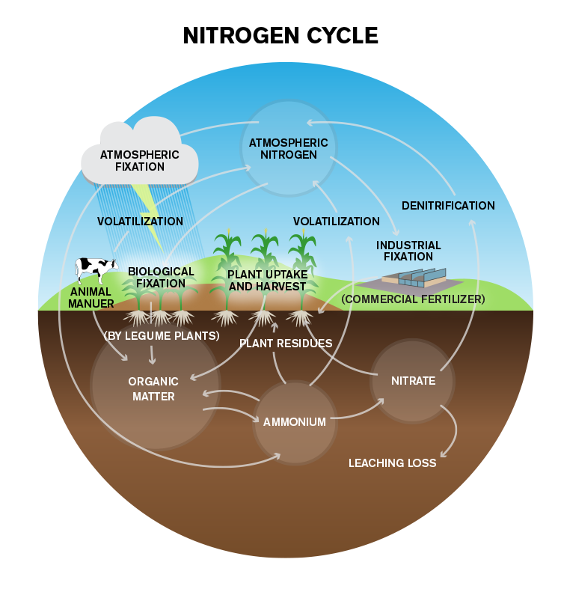

Plant Nitrogen Needs and Uptake
Plants absorb nitrogen from the soil as both NH₄⁺ and NO₃⁻ ions, but because nitrification is so pervasive in agricultural soils, most of the nitrogen is taken up as nitrate. Nitrate moves freely toward plant roots as they absorb water. Once inside the plant, NO₃⁻ is reduced to an NH₂ form and is assimilated to produce more complex compounds. Because plants require very large quantities of nitrogen, an extensive root system is essential to allowing unrestricted uptake. Plants with roots restricted by compaction may show signs of nitrogen deficiency even when adequate nitrogen is present in the soil.

Source: IPNI
Most plants take nitrogen from the soil continuously throughout their lives, and nitrogen demand usually increases as plant size increases. A plant supplied with adequate nitrogen grows rapidly and produces large amounts of succulent, green foliage. Providing adequate nitrogen allows an annual crop, such as corn, to grow to full maturity, rather than delaying it. A nitrogen-deficient plant is generally small and develops slowly because it lacks the nitrogen necessary to manufacture adequate structural and genetic materials. It is usually pale green or yellowish because it lacks adequate chlorophyll. Older leaves often become necrotic and die as the plant moves nitrogen from less important older tissues to more important younger ones.
On the other hand, some plants may grow so rapidly when supplied with excessive nitrogen that they develop protoplasm faster than they can build sufficient supporting material in cell walls. Such plants are often rather weak and may be prone to mechanical injury. Development of weak straw and lodging of small grains are an example of such an effect.

Fertilizer Management

Nitrogen Cycle
Nitrogen fertilizer rates are determined by the crop to be grown, yield goal and quantity of nitrogen that might be provided by the soil. Rates needed to achieve different yields with different crops vary by region, and such decisions are usually based on local recommendations and experience.

Factors that Determine the Quantity of Nitrogen Supplied by the Soil
- The quantity of nitrogen released from the soil organic matter
- The quantity of nitrogen released by decomposition of residues of the previous crop
- Any nitrogen supplied by previous applications of organic waste
- Any nitrogen carried over from previous fertilizer applications.

Such contributions can be determined by taking nitrogen credits (expressed in lb/acre) for these variables. For example, corn following alfalfa usually requires less additional nitrogen than corn following corn, and less nitrogen fertilizer is needed to reach a given yield goal when manure is applied. As with rates, credits are usually based on local conditions.
Soil testing is being suggested more often as an alternative to taking nitrogen credits. Testing soils for nitrogen has been a useful practice in the drier regions of the Great Plains for many years, and in that region, fertilizer rates are often adjusted to account for NO₃⁻ found in the soil prior to planting. In recent years, there has been some interest in testing cornfields for NO₃⁻ in the more humid regions of the eastern United States and Canada, utilizing samples taken in late spring, after crop emergence, rather than before planting. This strategy, the pre-side-dress nitrogen soil test (PSNT), has received a great deal of publicity and seems to provide some indication of whether additional side-dressed nitrogen is needed or not.

Fertilizer Placement
Placement decisions should maximize availability of nitrogen to crops and minimize potential losses. A plant’s roots usually will not grow across the root zone of another plant, so nitrogen must be placed where all plants have direct access to it. Broadcast applications accomplish this objective. Banding does also when all crop rows are directly next to a band. For corn, banding anhydrous ammonia or urea ammonium nitrate (UAN) in alternate row middles is usually as effective as banding in each middle because all rows have access to the fertilizer.
Moist soil conditions are necessary for nutrient uptake. Placement below the soil surface can increase nitrogen availability under dry conditions because roots are more likely to find nitrogen in moist soil with such placement. Injecting side-dressed UAN may produce higher corn yields than surface application in years when dry weather follows side-dressing. In years when rainfall occurs shortly after application, subsurface placement is not as critical.
Subsurface placement is normally used to control nitrogen losses. Anhydrous ammonia must be placed and sealed below the surface to eliminate direct volatilization losses of the gaseous ammonia. Volatilization from urea and UAN solutions can be controlled by incorporation or injection. Incorporating urea materials (mechanically or by rainfall shortly after application) is especially important in no-till situations in which volatilization is aggravated by large amounts of organic material on the soil surface. Applying small amounts of "starter" nitrogen as UAN in herbicide sprays, however, is usually of little concern.
Placing nitrogen with phosphorus often increases phosphorus uptake, particularly when nitrogen is in the NH₄⁺ form and the crop is growing in an alkaline soil. The reasons for the effect are not completely clear, but may be due to nitrogen increasing root activity and potential for phosphorus uptake, and nitrification of NH₄⁺ providing acidity, which enhances phosphorus solubility.

Timing of Nutrient Application
Timing has a major effect on the efficiency of nitrogen management systems. Nitrogen should be applied to avoid periods of significant loss and to provide adequate nitrogen when the crop needs it most. Wheat takes up most of its nitrogen in the spring and early summer, and corn absorbs most nitrogen in midsummer, so ample availability at these times is critical. If losses are expected to be minimal, or can be effectively controlled, applications before or immediately after planting are effective for both crops. If significant losses, particularly those due to denitrification or leaching, are anticipated, split applications, in which much of the nitrogen is applied after crop emergence, can be effective in reducing losses. Fall applications for corn can be used on well-drained soils, particularly if the nitrogen is applied as anhydrous ammonia amended with N-Serve®; however, fall applications should be avoided on poorly drained soils, due to an almost unavoidable potential for significant denitrification losses. When most of a crop’s nitrogen supply will be applied after significant crop growth or positioned away from the seed row (anhydrous ammonia or UAN banded in row middles), applying some nitrogen easily accessible to the seedling at planting ensures that the crop will not become nitrogen deficient before gaining access to the main supply of nitrogen.

