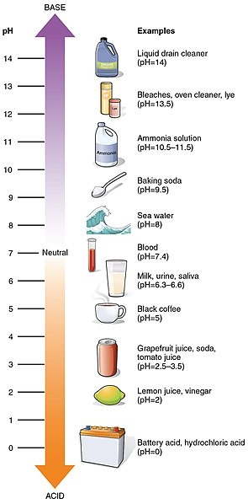

**The pH Scale**

**pH refers to the Power of Hydrogen and is the measure of Hydrogen ion concentration in a solution.**

**The pH scale goes from 0 to 14 with 0 being the most acidic and 14 the most basic or alkaline.**

**The middle (7) is neutral pH and is the ideal pH for water. Most aquatic animals can live with a pH ranging between 5.5 and 9.5**

**During the day, plants uptake carbon dioxide so water becomes more basic (higher pH). At night plants release carbon dioxide causing the water to become more acidic (lower pH).**