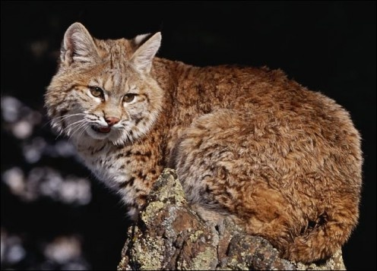

Bobcats
The bobcat is the most abundant wildcat in the U.S. and has the greatest range of all native North American cats. Bobcats are elusive and nocturnal, so they are rarely spotted by humans. Although they are seldom seen, they roam throughout much of North America and adapt well to such diverse habitats as forests, swamps, deserts, and even suburban areas.
Bobcats, sometimes called wildcats, are roughly twice as big as the average housecat. They have long legs, large paws, and tufted ears similar to those of their larger relative, the Canada lynx. Most bobcats are brown or brownish red with a white underbelly and short, black-tipped tail. The cat is named for its tail, which appears to be cut or "bobbed."
Fierce hunters, bobcats can kill prey much bigger than themselves, but usually eat rabbits, birds, mice, squirrels, and other smaller game. The bobcat hunts by stealth, but delivers a deathblow with a leaping pounce that can cover 10 feet (3 meters).
Bobcats are solitary animals. Females choose a secluded den to raise a litter of one to six young kittens, which will remain with their mother for 9 to 12 months. During this time they will learn to hunt before setting out on their own.
In some areas, bobcats are still trapped for their soft, spotted fur. North American populations are believed to be quite large, with perhaps as many as one million cats in the United States alone

Fast Facts
Type: Mammal

Diet: Carnivore

Average life span in the wild: 10 to 12 years

Size: Head and body, 26 to 41 in (66 to 104 cm); tail, 4 to 7 in (10 to 18 cm)

Weight: 11 to 30 lbs (5 to 14 kg)

.

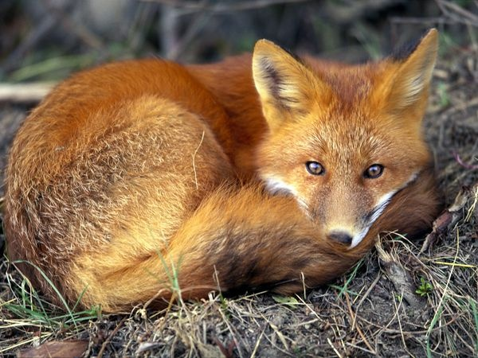
Red Fox
Habitat: Red foxes live around the world in many diverse habitats including forests, grasslands, mountains, and deserts. They also adapt well to human environments such as farms, suburban areas, and even large communities. The red fox's resourcefulness has earned it a legendary reputation for intelligence and cunning.
Red foxes are solitary hunters who feed on rodents, rabbits, birds, and other small game—but their diet can be as flexible as their home habitat. Foxes will eat fruit and vegetables, fish, frogs, and even worms. If living among humans, foxes will opportunistically dine on garbage and pet food.
Like a cat's, the fox's thick tail aids its balance, but it has other uses as well. A fox uses its tail (or "brush") as a warm cover in cold weather and as a signal flag to communicate with other foxes.
Foxes also signal each other by making scent posts—urinating on trees or rocks to announce their presence.
In winter, foxes meet to mate. The vixen (female) typically gives birth to a litter of 2 to 12 pups. At birth, red foxes are actually brown or gray. A new red coat usually grows in by the end of the first month, but some red foxes are golden, reddish-brown, silver, or even black. Both parents care for their young through the summer before they are able to strike out on their own in the fall.
Red foxes are hunted for sport, though not extensively, and are sometimes killed as destructive pests or frequent carriers of rabies.
Type: Mammals
Diet: Omnivore
Average life span: 2 to 4 years
Size: Head and body – 18 to 33.75 inches (46 to 86 cm)
Tail – 12 to 21.75 inches (30.5 to 55.5 cm)
Weight: 6.5 to 24 lbs. (3 to 11kg)

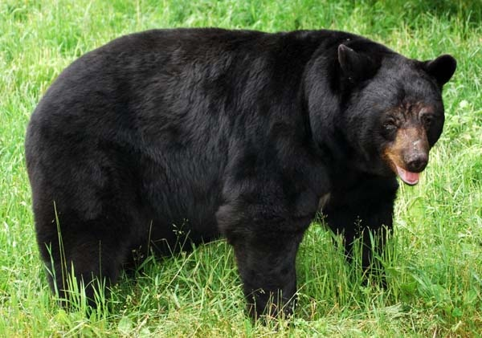

Black Bear
Black bears are North America's most familiar and common bears. They typically live in forests and are excellent tree climbers, but are also found in mountains and swamps. Despite their name, black bears can be blue-gray or blue-black, brown, cinnamon, or even (very rarely) white.
Black bears are very opportunistic eaters. Most of their diet consists of grasses, roots, berries, and insects. They will also eat fish and mammals—including carrion—and easily develop a taste for human foods and garbage. Bears who become habituated to human food at campsites, cabins, or rural homes can become dangerous and are often killed—thus the frequent reminder: Please don't feed the bears!
Solitary animals, black bears roam large territories, though they do not protect them from other bears. Males might wander a 15- to 80-square-mile (39- to 207-square-kilometer) home range.
When winter arrives, black bears spend the season dormant in their dens, feeding on body fat they have built up by eating ravenously all summer and fall. They make their dens in caves, burrows, brush piles, or other sheltered spots—sometimes even in tree holes high above the ground. Black bears den for various lengths of time governed by the diverse climates in which they live, from Canada to northern Mexico.
Female black bears give birth to two or three blind, helpless cubs in mid-winter and nurse them in the den until spring, when all emerge in search of food. The cubs will stay with their very protective mother for about two years.

Fast Facts
Type: Mammal

Diet: Omnivore

Average life span in the wild: 20 years

Size: 5 to 6 ft (1.5 to 1.8 m) long

Weight: 200 to 600 lbs (90 to 270 kg)

Group name: Sleuth or Sloth

Did you know? Black bears are not true hibernators. During their winter dormant period, though, they do not eat, drink, urinate, or defecate, but may wake up if disturbed.

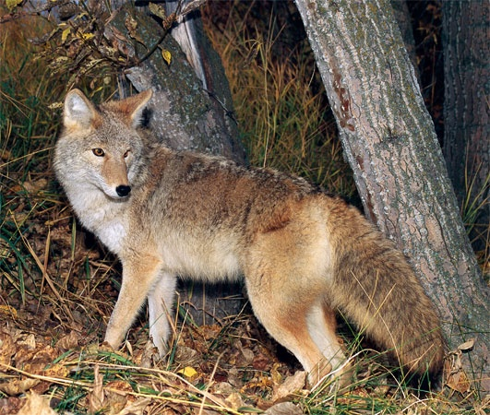

Coyote
The coyote appears often in the tales and traditions of Native Americans—usually as a very savvy and clever beast. Modern coyotes have displayed their cleverness by adapting to the changing American landscape. These members of the dog family once lived primarily in open prairies and deserts, but now roam the continent's forests and mountains. They have even colonized cities like Los Angeles, and are now found over most of North America. Coyote populations are likely at an all-time high.
These adaptable animals will eat almost anything. They hunt rabbits, rodents, fish, frogs, and even deer. They also happily dine on insects, snakes, fruit, grass, and carrion. Because they sometimes kill lambs, calves, or other livestock, as well as pets, many ranchers and farmers regard them as destructive pests.
Coyotes are formidable in the field where they enjoy keen vision and a strong sense of smell. They can run up to 40 miles (64 kilometers) an hour. In the fall and winter, they form packs for more effective hunting.
Coyotes form strong family groups. In spring, females den and give birth to litters of three to twelve pups. Both parents feed and protect their young and their territory. The pups are able to hunt on their own by the following fall.
Coyotes are smaller than wolves and are sometimes called prairie wolves or brush wolves. They communicate with a distinctive call, which at night often develops into a raucous canine chorus.

Fast Facts
Type: Mammal

Diet: Omnivore

Average life span in the wild: Up to 14 years

Size: Head and body, 32 to 37 in (81 to 94 cm); Tail, 16 in (41 cm)

Weight: 20 to 50 lbs (9 to 23 kg)

Group name: Pack

Did you know? Coyotes are very good swimmers. In areas of the northeast United States, where coyotes have migrated since the 20th century, the animals have colonized the Elizabeth Islands of Massachusetts.

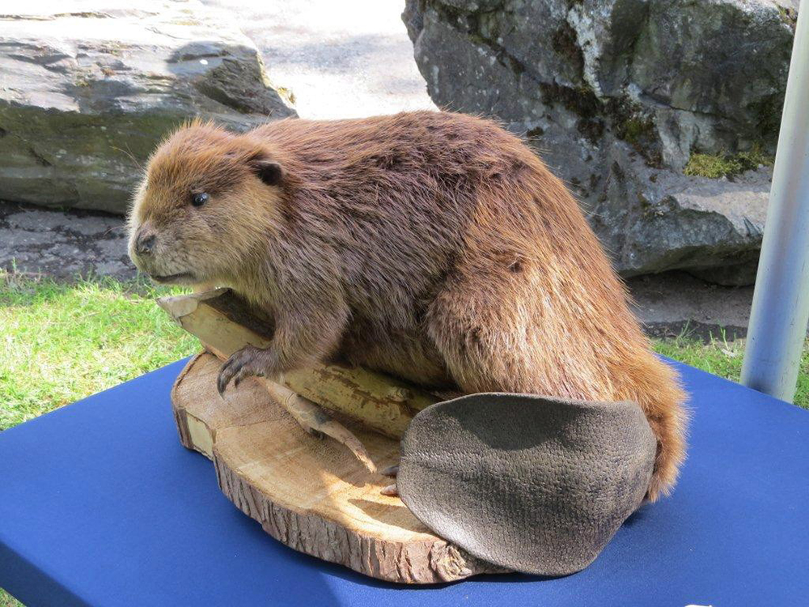

Beaver
Beavers are famously busy, and they turn their talents to reengineering the landscape as few other animals can. When sites are available, beavers burrow in the banks of rivers and lakes. But they also transform less suitable habitats by building dams. Felling and gnawing trees with their strong teeth and powerful jaws, they create massive log, branch, and mud structures to block streams and turn fields and forests into the large ponds that beavers love.
Domelike beaver homes, called lodges, are also constructed of branches and mud. They are often strategically located in the middle of ponds and can only be reached by underwater entrances. These dwellings are home to extended families of monogamous parents, young kits, and the yearlings born the previous spring.
Beavers are among the largest of rodents. They are herbivores and prefer to eat leaves, bark, twigs, roots, and aquatic plants.
These large rodents move with an ungainly waddle on land but are graceful in the water, where they use their large, webbed rear feet like swimming fins, and their paddle-shaped tails like rudders. These attributes allow beavers to swim at speeds of up to five miles (eight kilometers) an hour. They can remain underwater for 15 minutes without surfacing, and have a set of transparent eyelids that function much like goggles. Their fur is naturally oily and waterproof.
There are two species of beavers, which are found in the forests of North America, Europe, and Asia. These animals are active all winter, swimming and foraging in their ponds even when a layer of ice covers the surface.

Fast Facts
Type: Mammal

Diet: Herbivore

Average life span in the wild: Up to 24 years

Size: Head and body, 23 to 39 in (60 to 100 cm); tail, 7.75 to 12 in (20 to 30.5 cm)

Weight: 60 lbs (27 kg)

Group name: Colony

Did you know? Beavers are second only to humans in their ability to manipulate and change their environment.
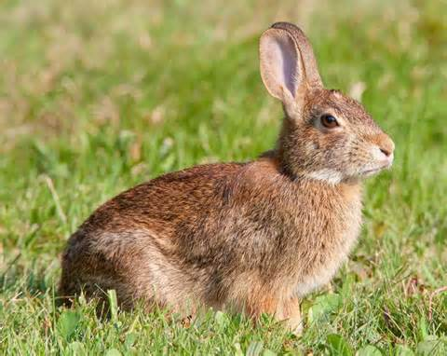

Cottontail Rabbit
There are several species of cottontail rabbit, but the eastern cottontail is the most common. This ubiquitous animal can be found from Canada to South America and, in the United States, from the East Coast to the Great Plains. Cottontails range from reddish brown to gray, but all feature the distinctive "cotton ball" tail for which they are named.
These rabbits seek out habitat on the fringes of open spaces, such as fields, meadows, and farms, but can adapt to other habitats—including those of humans.
They browse at night on grasses and herbs and are fond of garden fare such as peas and, of course, lettuce. In winter, their diet becomes a bit coarse and consists of bark, twigs, and buds. During the day, cottontails often remain hidden in vegetation. If spotted, they flee from prey with a zigzag pattern, sometimes reaching speeds of up to 18 miles (29 kilometers) an hour.
Females give birth in shallow ground nests, to young so helpless that perhaps only 15 percent survive their first year. Fortunately, rabbits breed three or four times every year and produce three to eight young each time. Young rabbits mature quickly and are self-sufficient after only four or five weeks. They are sexually mature after only two or three months, so populations are able to grow with staggering speed.
Cottontails are plentiful and can be problematic for farmers; they are also a popular game animal.

Fast Facts
Type: Mammal
Diet: Herbivore
Average life span in the wild: Less than 3 years
Size: 15.5 to 18.75 in (39.5 to 47.7 cm)
Weight: 28 to 54 oz (800 to 1533 g)

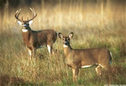
White tail deer
White-tailed deer, the smallest members of the North American deer family, are found from southern Canada to South America. In the heat of summer they typically inhabit fields and meadows using clumps of broad-leaved and coniferous forests for shade. During the winter they generally keep to forests, preferring coniferous stands that provide shelter from the harsh elements. ?"White-tailed” refers to the white underside of the deer’s tail, which it displays and wags when it senses danger.
Adult white-tails have reddish-brown coats in summer which fade to a duller grayish-brown in winter. Male deer, called bucks, are easily recognizable in the summer and fall by their prominent set of antlers, which are grown annually and fall off in the winter. Only the bucks grow antlers, which bear a number of tines, or sharp points. During the mating season, also called the rut, bucks fight over territory by using their antlers in sparring matches.
Female deer, called does, give birth to one to three young at a time, usually in May or June and after a gestation period of seven months. Young deer, called fawns, wear a reddish-brown coat with white spots that helps them blend in with the forest.
White-tailed deer are herbivores, leisurely grazing on most available plant foods. Their stomachs allow them to digest a varied diet, including leaves, twigs, fruits and nuts, grass, corn, alfalfa, and even lichens and other fungi. Occasionally venturing out in the daylight hours, white-tailed deer are primarily nocturnal or crepuscular, browsing mainly at dawn and dusk.
In the wild, white-tails, particularly the young, are preyed upon by bobcats, mountain lions, and coyotes. They use speed and agility to outrun predators, sprinting up to 30 miles (48 kilometers) per hour and leaping as high as 10 feet (3 meters) and as far as 30 feet (9 meters) in a single bound.
Although previously depleted by unrestricted hunting in the United States, strict game-management measures have helped restore the white-tailed deer population.
Type: Mammal

Diet: Herbivore

Average life span in captivity: 6 to 14 years

Size: 6 to 7.75 ft (1.8 to 2.4 m)

Weight: 110 to 300 lbs (50 to 136 kg)
Group name: Herd

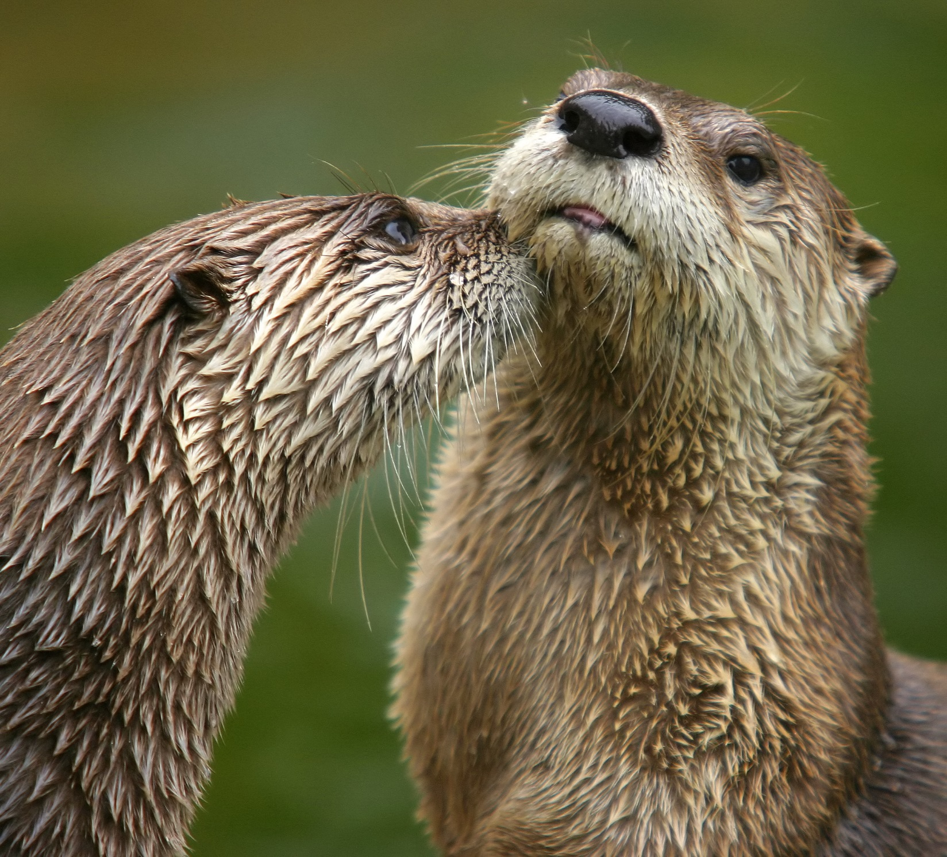

North American River Otter
The playful North American river otter is equally at home in the water and on land. It makes its home in a burrow near the water's edge, and can thrive in river, lake, swamp, or estuary ecosystems. Otter abodes feature numerous tunnels—one of which usually allows them to come and go from the water.
These otters swim by propelling themselves with their powerful tails and flexing their long bodies. They also have webbed feet, water repellent fur to keep them dry and warm, and nostrils and ears that close in the water. They remain active in winter, using ice holes to surface and breathe. They can hold their breath underwater for some eight minutes.
River otters, members of the weasel family, hunt at night and feed on whatever might be available. Fish are a favorite food, but they also eat amphibians, turtles, and crayfish.
On land, river otters can bound and run quite well, if not quite as effectively as they swim. They love to playfully slide down snow-covered, icy, or muddy hills—often ending with a splash in the water. Otter families of mother and children can be seen enjoying such fun, which also teaches survival skills.
Males do not help raise young otters. Females retreat to their underground dens to deliver litters of one to six young. When the young are only about two months old, they get an advanced swimming lesson—their mother pushes them into the water. Otters are natural swimmers and, with parental supervision, they soon get the hang of it.
These otters' range has been greatly reduced by habitat loss, though they exist in such numbers that they are trapped in some locales. Otters are also very sensitive to environmental pollution.

Fast Facts
Type: Mammal

Diet: Carnivore

Average life span in the wild: 8 to 9 years

Size: Head and body, 21.75 to 31.5 in (55 to 80 cm); tail, 11.75 to 19.75 in (30 to 50 cm)

Weight: 11 to 30 lbs (5 to 14 kg)

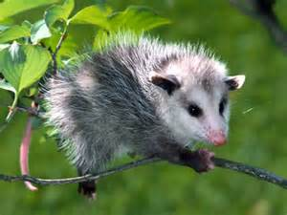

Opposum
There are more than 60 different species of opossum, which are often called possums. The most notable is the Virginia opossum or common opossum—the only marsupial (pouched mammal) found in the United States and Canada.
A female opossum gives birth to helpless young as tiny as honeybees. Babies immediately crawl into the mother's pouch, where they continue to develop. As they get larger, they will go in and out of the pouch and sometimes ride on the mother's back as she hunts for food. Opossums may give birth to as many as 20 babies in a litter, but fewer than half of them survive. Some never even make it as far as the pouch.
Opossums are scavengers, and they often visit human homes or settlements to raid garbage cans, dumpsters, and other containers. They are attracted to carrion and can often be spotted near roadkill. Opossums also eat grass, nuts, and fruit. They will hunt mice, birds, insects, worms, snakes, and even chickens.
These animals are most famous for "playing possum." When threatened by dogs, foxes, or bobcats, opossums sometimes flop onto their sides and lie on the ground with their eyes closed or staring fixedly into space. They extend their tongues and generally appear to be dead. This ploy may put a predator off its guard and allow the opossum an opportunity to make its escape.
Opossums are excellent tree climbers and spend much of their time aloft. They are aided in this by sharp claws, which dig into bark, and by a long prehensile (gripping) tail that can be used as an extra limb. Opossums nest in tree holes or in dens made by other animals.
These animals are widespread and are sometimes hunted as food, particularly in the southern United States.

Fast Facts
Type: Mammal

Diet: Omnivore

Size: Length from nose to tail, 2.5 ft (76 cm)

Weight: 8.8 to 13.2 lb (4 to 6 kg)

Group name: Passel

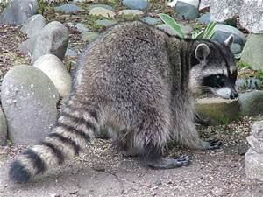

Raccoon
Bandit-masked raccoons are a familiar sight just about everywhere, because they will eat just about anything. These ubiquitous mammals are found in forests, marshes, prairies, and even in cities. They are adaptable and use their dexterous front paws and long fingers to find and feast on a wide variety of fare.
In the natural world, raccoons snare a lot of their meals in the water. These nocturnal foragers use lightning-quick paws to grab crayfish, frogs, and other aquatic creatures. On land, they pluck mice and insects from their hiding places and raid nests for tasty eggs.
Raccoons also eat fruit and plants—including those grown in human gardens and farms. They will even open garbage cans to dine on the contents.
These ring-tailed animals are equally opportunistic when it comes to choosing a denning site. They may inhabit a tree hole, fallen log, or a house's attic. Females have one to seven cubs in early summer. The young raccoons often spend the first two months or so of their lives high in a tree hole. Later, mother and children move to the ground when the cubs begin to explore on their own.
Raccoons in the northern parts of their range gorge themselves in spring and summer to store up body fat. They then spend much of the winter asleep in a den. There are six other species of raccoons, in addition to the familiar northern (North American) raccoon. Most other species live on tropical islands.

Fast Facts
Type: Mammal

Diet: Omnivore

Average life span in the wild: 2 to 3 years

Size: 23.75 to 37.5 in (60 to 95 cm)

Weight: 4 to 23 lbs (1.8 to 10.4 kg)

Group name: Nursery

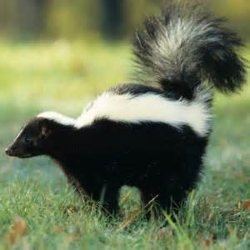

Skunk
Skunks are legendary for their powerful predator-deterrent—a hard-to-remove, horrible-smelling spray. A skunk's spray is an oily liquid produced by glands under its large tail. To employ this scent bomb, a skunk turns around and blasts its foe with a foul mist that can travel as far as ten feet (three meters).
Skunk spray causes no real damage to its victims, but it sure makes them uncomfortable. It can linger for many days and defy attempts to remove it. As a defensive technique, the spray is very effective. Predators typically give skunks a wide berth unless little other food is available.
There are many different kinds of skunks. They vary in size (most are house cat-sized) and appear in a variety of striped, spotted, and swirled patterns—but all are a vivid black-and-white that makes them easily identifiable and may alert predators to their pungent potential.
Skunks usually nest in burrows constructed by other animals, but they also live in hollow logs or even abandoned buildings. In colder climates, some skunks may sleep in these nests for several weeks of the chilliest season. Each female gives birth to between two and ten young each year.
Skunks are opportunistic eaters with a varied diet. They are nocturnal foragers who eat fruit and plants, insects, larvae, worms, eggs, reptiles, small mammals, and even fish. Nearly all skunks live in the Americas, except for the Asian stink badgers that have recently been added to the skunk family.

Fast Facts
Type: Mammal

Diet: Omnivore

Average life span in the wild: 3 years

Size: Head and body, 8 to 19 in (20 to 48 cm); tail, 5 to 15 in (13 to 38 cm)

Weight: 7 oz to 14 lbs (198 g to 6 kg)

Group name: Surfeit

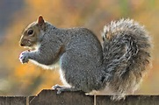

Squirrel
Squirrels are familiar to almost everyone. More than 200 squirrel species live all over the world, with the notable exception of Australia.
The tiniest squirrel is the aptly named African pygmy squirrel—only five inches (thirteen centimeters) long from nose to tail. Others reach sizes shocking to those who are only familiar with common tree squirrels. The Indian giant squirrel is three feet (almost a meter) long.
Like other rodents, squirrels have four front teeth that never stop growing so they don't wear down from the constant gnawing. Tree squirrels are the types most commonly recognized, often seen gracefully scampering and leaping from branch to branch. Other species are ground squirrels that live in burrow or tunnel systems, where some hibernate during the winter season.
Ground squirrels eat nuts, leaves, roots, seeds, and other plants. They also catch and eat small animals, such as insects and caterpillars. These small mammals must always be wary of predators because they are tasty morsels with few natural defenses, save flight. Sometimes groups of ground squirrels work together to warn each other of approaching danger with a whistling call.
Tree squirrels are commonly seen everywhere from woodlands to city parks. Though they are terrific climbers, these squirrels do come to the ground in search of fare such as nuts, acorns, berries, and flowers. They also eat bark, eggs, or baby birds. Tree sap is a delicacy to some species.
Flying squirrels are a third, adaptable type of squirrel. They live something like birds do, in nests or tree holes, and although they do not fly, they can really move across the sky. Flying squirrels glide, extending their arms and legs and coasting through the air from one tree to another. Flaps of skin connecting limbs to body provide a winglike surface. These gliding leaps can exceed 150 feet (46 meters). Flying squirrels eat nuts and fruit, but also catch insects and even baby birds.
Whether they dwell high in a tree or in an underground burrow, female squirrels typically give birth to two to eight offspring. Babies are blind and totally dependent on their mothers for two or three months. Mothers may have several litters in a year, so most squirrel populations are robust.

Fast Facts
Type: Mammal Diet: Omnivore Size: 5 to 36 in (13 to 91 cm)

Weight: 0.5 oz to 4 lbs (14 g to 2 kg) Group name: Scurry or Dray

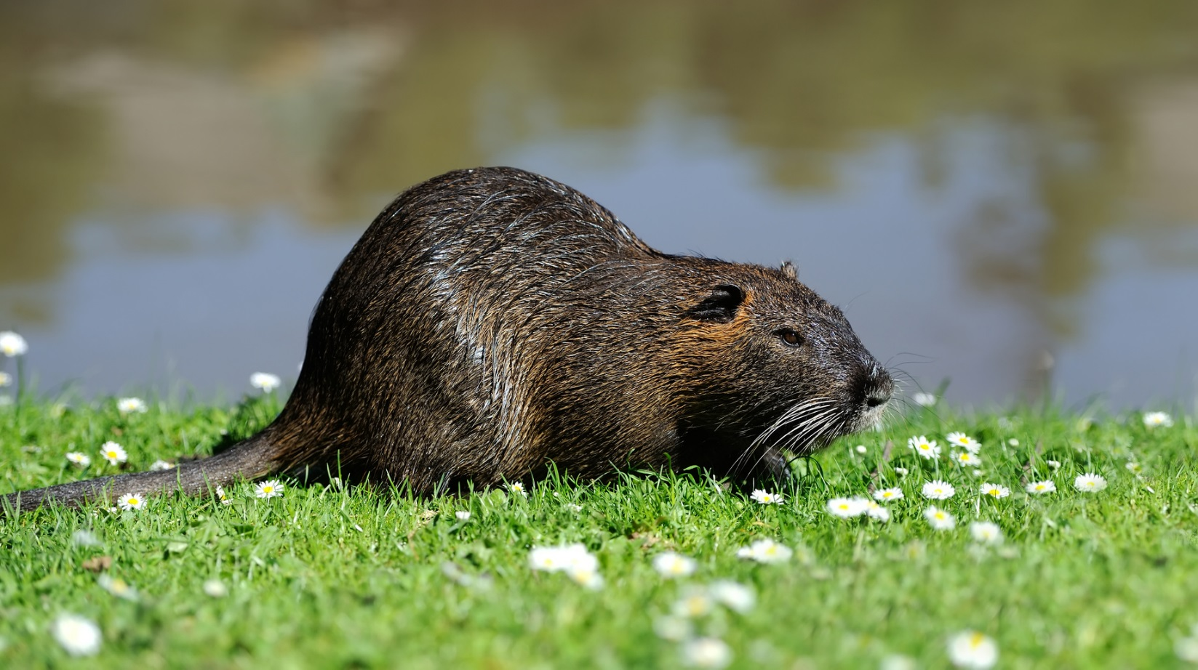

Muskrat
Muskrats are large rodents, and therefore are related to rats, mice, voles, gerbils, hamsters and lemmings. These aquatic animals look a lot like their relatives. They are quite round, with short legs and almost invisible ears.

Size
Muskrats are around the size of large rats or cottontail rabbit. Adults vary from 16 to 25 inches in total length and weigh from 1 1/2 to 4 pounds. The average weight is about 2 1/2 pounds. Muskrats have small eyes and ears. The front legs are short while the hind legs are longer, stronger and have partially webbed feet. The black, scaly tail is flattened vertically (like the rudder of a ship) and is almost as long as the body.
Habitat
Aquatic habitats like rivers, streams, drainage ditches, marshes, lakes and ponds are home to muskrats. Those that live in areas with shallow, stable water (like marshes) often build dome-shaped houses by cutting and piling up cattails, bulrushes or other aquatic vegetation. Some are 8 feet or more in diameter at the base and have walls 1 to 2 feet thick. Tunnels angle upward from the underwater entrances (usually two) to an inside chamber that's hollowed out above the water level. This allows the muskrats to stay warm and dry in their nest chamber while resting and raising their young. Muskrats that live in rivers, ditches and ponds usually don't build houses. Instead, they burrow into the bank. Burrows dug into the dams of man-made ponds can wash out during high water, causing the ponds to drain.
Habits
Muskrats are most active at night, but it's not uncommon to see one feeding or building a house in the early morning or late afternoon. They spend most of their time within a few hundred feet of their dens or houses. However, some move away from their homes in late summer or early fall and can be seen traveling through areas far from water. Similar overland movements can occur in the spring during breeding season.
Foods
In marshes, muskrats eat the roots and stems of cattail, bulrush, arrowhead, duckweed and water-lily. Clover, corn and grasses are common foods in agricultural areas. Although they are considered to be herbivores (plant-eaters), muskrats sometimes eat freshwater clams, snails, crayfish, fish and frogs. Feeding piles or platforms of shredded vegetation often accumulate where muskrats make a habit of stopping to eat their meals.
Reproduction
The breeding season starts in late winter and ends in September. Pregnancy averages 28 days. Females usually have two litters, sometimes three, per year. A typical litter has four to seven young.

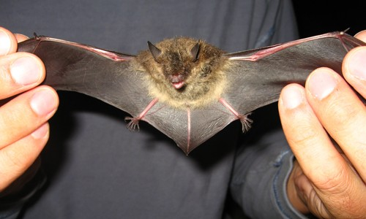

Little Brown Bat
- While male brown bats spend all summer living alone except to breed, females roost in large colonies consisting of 1,000 bats. They are known to migrate 150 mi (250 km) between the summer and winter roosting sites.
- While flying little brown bats emit 20 calls per second however while chasing insects they produce 200 calls each second.
Feeding Ecology & Diet
- Like most bats species, little brown bats are insectivorous. They hunt in flight and their prey includes flies, mosquitoes, wasps, beetles, midges, gnats, mayflies, and moths. It is estimated that little brown bats eat up to 4,000 insects per night.
- They are likely to find aquatic insects because their habitats are near short water bodies.
- They will be active during the early part of evening or at dawn.
Reproductive Biology
- After a gestation period of about 50 – 60 days single young is born. The birth mostly occurs in the mid-summer or late spring.
- The young will remain in the nest for almost a month after which it flies.
- In about two months the young will reach the full size.
- They attain maturity at 1 – 2 year age and their body is about the size of an adult human thumb.
- In the wild they have lived up to 33 years.
- Predators of little brown bats include raptors that hunt bats in flight. They are also vulnerable to raccoons as they are able to reach the bat’s roosting site. Snakes, rats, and birds also prey on little brown bats.

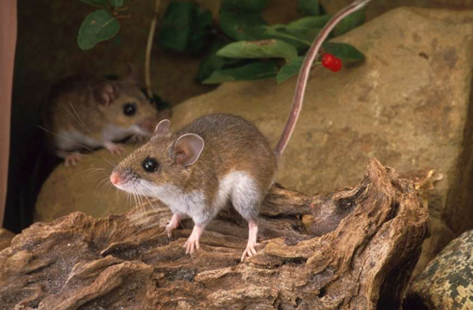

Deer Mouse
Deer mice are small, white footed rodents that are quite prevalent in North America. These tiny mammals are a concern since they are the carriers of Lyme disease and Hantavirus, which are deadly to humans.

Behavior
The deer mice are nocturnal animals adept in climbing trees. However, they remain mostly active on the ground, spending most of the time around food cache and nests, which consist of twigs, leaves, stems, roots, and other plant materials. Some construct their own burrows below the ground level while others build nests in tree hollows, stumps, bush piles, and logs.
- Unlike the house mouse (Musmusculus), the deer mouse has a bicolored, slightly furry tail. Moreover, its ears and eyes are comparatively larger than those of the house mouse.
- Most young deer mouse disperses after weaning and may travel up to 152 m from its place of birth in order to establish its own territory.

Size: 12-22 cm long, tail length is 4.5-10.5 cm
Weight: 10-24 grams
Color: Dark/light brown back; white undersides and legs; the tail is whitish at the bottom
Life expectancy: Less than a year but have lived up to 8 years in captivity.

Diet Omnivorous; seeds, leaves, fruits, fungi, and arthropods like caterpillars, heteropterans, and spiders
Can reproduce 1-9 young; 3-5 babies are common Has several litters per year
What eats deer mice? Snakes, minks, martens, skunks, weasels, bobcats, domestic cats,
foxes, coyotes, owls, ringtails

