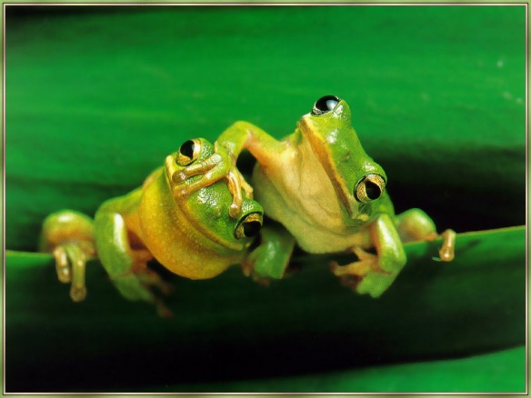
FROGS BY THE BOG
This program works very well for K through 1. There is a deck by a fenced pond at Buckingham Elementary School and if you do this program in May, you can actually see tadpoles and frogs.
Materials (books and life cycle info and stuff to make frog crowns are in a green District bag labelled FROGS by the BOG on shelf in storage unit):
- Get the book A Frog in the Bog by Karma Wilson
- A thin paperback book entitled FROGS by Kevin Holmes
- 1 or 2 large blue tarps
- Small stool to sit on while you read if outside
Program: Lay the large blue tarp on the ground and have the children sit on it and pretend this is the water. Then highlight the book on Frogs and show the students the pictures. Show life cycle posters and plastic life cycle figurines.
- Tell students that frogs are amphibians. There are four conditions that must be met in order to be an amphibian:
- Cold blooded – a frog’s body temperature is the same as their environment. This means if it is 90 degrees outside, the frog’s blood is 90 degrees, if it is 45 degrees, their blood is 45 degrees and so on. Human beings and other mammals are warm blooded. Our blood is about 98.6 degrees whether it is 100 degrees outside or it is snowing and below 30 degrees. Frogs have to hibernate during cold weather by burying themselves in the ground or sitting on the bottom of a pond.
- Vertebrates – they have a backbone
- They live part of their lives in water and part of their lives on land
- They lay eggs, but their eggs don’t have shells like chickens or birds

- Then highlight the book on Frogs by Kevin J. Holmes
- There are over 4,100 different kinds of frogs
- Frogs are many colors—green, brown, red, yellow, blue, orange or black. Some frogs are more than one color. (pages 5,7 & 9 in book). There is also a frog called a glass frog that is see through. This frog lives in South America (show photo)
- How big are frogs? Frogs can be as little as ½ inch or as big as 2 feet like the Goliath Frog (show photo)
- How old do frogs live to be? Most frogs live for about 3 years, but there is a flathead frog in Australia that lives to be 10 years
- What sound does a frog make? Ribbit! Frogs blow up their throat to make sounds. See photo on page 13
- What do frogs eat? They eat insects, worms, small fish, slugs and sometimes mice. They catch them with their long, sticky tongue and most frogs swallow them whole without chewing. See photo on page 17. Frogs use their eyes to swallow. They pull their eyes inside their heads. Their eyes are so large that they push food down the frog’s throat.
- What eats frogs? Frogs have to look out for fish, otters, skunks, snakes, birds and turtles. All these creatures like to eat frogs. See photo on page 19
- Are frogs born hopping about? No, frogs start off as eggs. Show life cycle posters and plastic life cycle figurines.
- How do frogs help people? Frogs help people by eating insects. Some insects spread illness to people and other insects damage crops. Scientists use the poison from poison dart frogs to make pain medicine.

- Then read the book: A Frog in the Bog. This is a very funny book and the children love it.
If program is outdoors, follow up with leap frog relay.
If program is indoors, can make frog crowns or frog hands.

