Water Temperature Test
What You'll Need:
- Sample container with your collected water sample.
- Protective gloves.
- Thermometer from your test kit.
Use of the thermometer: The temperature is indicated by a liquid crystal number on the Low Range thermometer and a green display on the High Range thermometer, as shown in the diagram below.
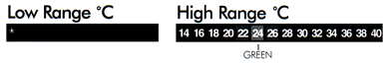
Temperature Test Procedure:
- Take the adhesive back off the thermometer and stick them to something that will make them easier for you to grasp.
- Wear protective gloves. Then, place the thermometer four inches below the water surface of your sample for one minute.
- Remove the thermometer from your sample, read the temperature and record it on your field data sheet as degrees Celsius.

