Munsell Color System – Just as paint stores have pages of color chips, soil scientists use a book of color chips that use the Munsell System of Color Notation. This system allows for direct comparison of soils anywhere in the world. It has 3 components:
- hue (a specific color in relation to Red, Yellow, Green, Blue and Purple)
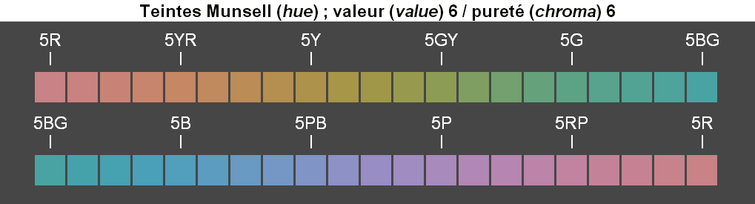
- value (lightness and darkness with 0 being absolute black, 5 being neutral gray and 10 being absolute white)
- chroma (color intensity beginning at 0 for neutral grays and increasing to a maximum of 20. If the soil has 0 chroma and 0 hue, the letter N (neutral) takes the place of hue designation.
Soil is held next to the chips to find a visual match and assigned the corresponding Munsell notation. For example, a brown soil may be noted as hue value/chroma (10YR 5/3).
Comparison of soil color should be done without sunglasses and in normal sunlight.

Interesting fact: Carpet manufacturers use Munsell soil colors to match carpet colors to local soils so that the carpet will not show the dirt (soil) tracked into the house.
So we have Red Desert soils in California, Arizona and Nevada and Gray Desert soils in Idaho, Utah, and Nevada. We have White Sands in New Mexico and Green Sands along the Atlantic coast. The Red River between Oklahoma and Texas carries red sediment downstream. The Yellow River in China carries yellow sediment. Surface soils in the Great Plains and Corn Belt are dark due to organic matter. Color is affected by minerals and environment. Aerobic environments (with oxygen) have uniform or subtly changing colors and anaerobic (lacking oxygen), wet environments disrupt color flow and have patterns and points of accents.
Mineral Color
Goethite Yellow to strong brown
Hematite Red
Lepidocrocite Reddish yellow
Ferrihydrite Dark Red
Glauconite Dark gray
Iron sulfide Black
Pyrite Black (metallic)
Jarosite Pale yellow
Todorokite Black
Humus Black
Calcite White
Dolomite White
Gypsum Pale brown
Quartz Light gray

