Virginia Standard Science 2.7

The student will investigate and understand that weather and seasonal changes affect plants, animals, and their surroundings.

Great video on erosion in Virginia: http://virginiatrekkers.com/StMarysFalls/Podcast.html

What causes valleys to form? Why do streams and lakes get muddy after a rain storm? Why are the rocks at the bottom of a river usually round? The answer to all these questions is EROSION!
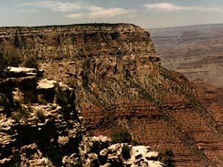
Erosion is the process by which the surface of the Earth gets worn down. Erosion can be caused by natural elements such as wind and glacial ice. But anyone who has ever seen a picture of the Grand Canyon knows that nothing beats the slow steady movement of water when it comes to changing the Earth.
The key to erosion is something called "fluid flow." Water, air, and even ice are fluids because they tend to flow from one place to another due to the force of gravity. Of the three, liquid water is the most common agent of erosion because there's so much of it on the surface of the Earth.

Here's what you'll need:  • 2 large disposable aluminum lasagna pans  • Some good old fashioned dirt (natural soil from a garden, NOT potting soil from a bag)  • A watering can  • A magnifying glass  • 2 or 3 books or wooden boards about 1/2-inch thick each  • A pair of pointy scissors or the needle of a drawing compass | 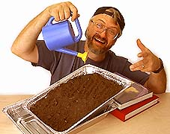

Here's what to do:
1. Pour the dirt into one of the pans so that it makes a layer on the bottom 2 to 3 inches deep. Smooth the soil out so that it is as even as possible on the top.
2. Examine the soil closely with the magnifier. Touch it and run it through your fingers. What is the soil made of? Does it all feel the same? How do you think the different soil parts would react if water was poured on them?
3. Use the scissors or compass needle to punch 6 small holes in one end of the tray.
4. Place the second pan under the end of the soil-filled pan where the holes are. (The second pan will catch the water as it leaves the top pan.)
5. Slip 2 or 3 books under the other end of the soil-filled pan so that it is propped up about 2 inches higher than the end with the holes punched in it.
How does rain shape the Earth? Try it yourself! Pour water from the watering can into the raised end of the dirt-filled pan. What happens to the surface of the soil when the water first hits it? What happens to the water that comes out of the dirt-filled pan and collects in the second pan?
Here are some other questions to consider: Do you think it matters if the soil starts out wet or dry? What would happen if you added a few more books under the pan to make a steeper slope? Do all the soil particles get pushed equally by the water? (Note: Make sure you carefully study the soil first because not all soil is created equal!)
Before you try this Science Lab, predict what will happen with your classmates. When you've finished the Science Lab, share your results with the rest of your class.

