MINERAL LAB

Get a mineral test kit, record sheet and choose a mineral to identify. Go through the following steps and record your answers on your record sheet. Check your answer on the back side of your record sheet. If you have time, return your mineral to the box and select another one to identify.

- Color
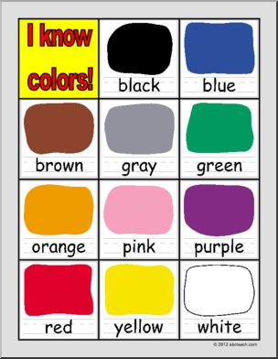
Look at your mineral. What colors do you see? Record your answer on your record sheet under color.
Note: Color is the least reliable property for identification.

- Luster: Look at your mineral again. How does it reflect light. Look at the pictures below to determine the luster:
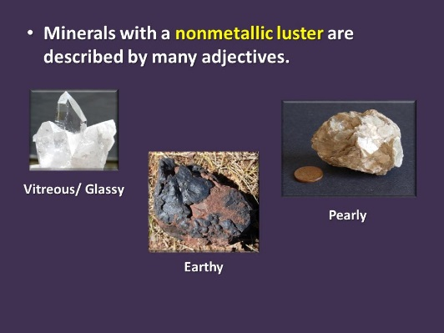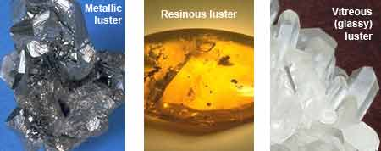
- Is it metallic (shiny and gold or silver color) if so write metallic on your answer sheet under luster. If not, go to #2

- Is it non-metallic (does not look like metal in color but still may be shiny). Non-metallic includes:
Pearly Vitreous Resinous Silky Earthy (dull)
- Streak: Take your mineral and draw a line on either the white porcelain streak plate or the black porcelain streak plate. What color is the streak? Record your answer on your record sheet under streak
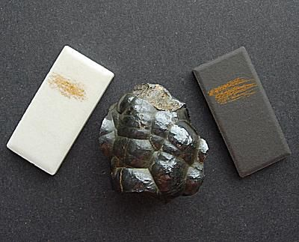

- Hardness: A mineral’s hardness is its resistance to scratching.
- Fingernail – 2.5 Use your fingernail and try to scratch the mineral
- Penny – 3.0 If your fingernail doesn’t scratch it, use the penny
- Nail – 5.0 If the penny doesn’t scratch it, try the nail
- Glass – 5.6 If the nail doesn’t scratch it, try the glass plate
- Streak plate – 7.5 If the glass plate doesn’t scratch it, try the streak plate
- If none of these scratch it, list the hardness at 8 – 10
- Record your answer on the record sheet under hardness
