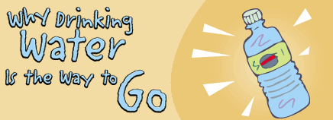

What do you, the trees, and a hamster have in common? Give up? You all need water. All living things must have water to survive, whether they get it from a water fountain, a rain cloud, or a little bottle attached to the side of a hamster cage.
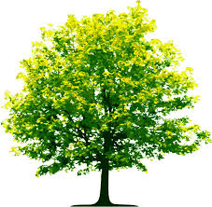
Without water, your body would stop working properly. Water makes up more than half of your body weight, and a person can't survive for more than a few days without it.

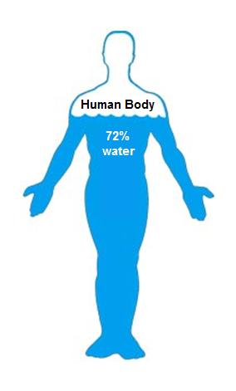
Why? Your body has lots of important jobs and it needs water to do many of them. For instance, your blood, which contains a lot of water, carries oxygen to all the cells of your body. Without oxygen, those tiny cells would die and your body would stop working.

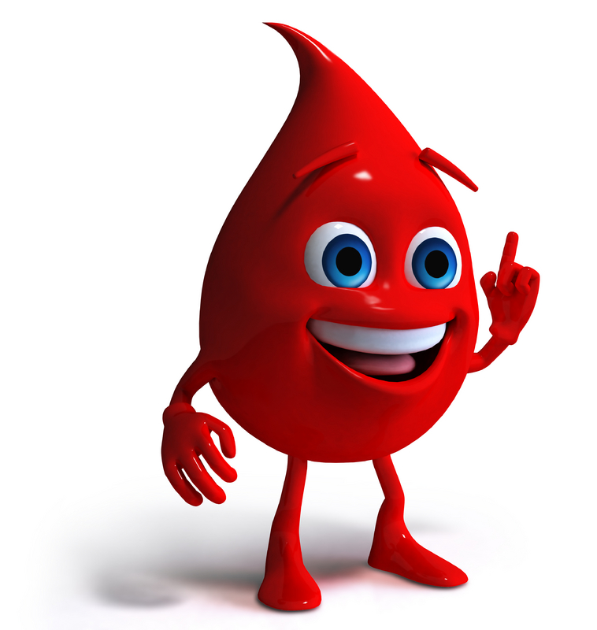
Water is also in lymph (say: limf), a fluid that is part of your immune system, which helps you fight off illness.

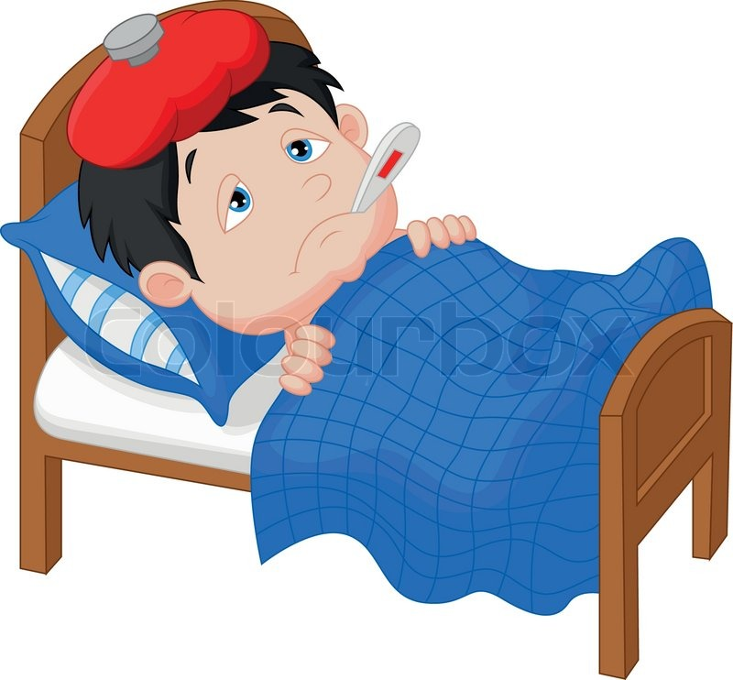

You need water to digest your food and get rid of waste, too. Water is needed for digestive juices, urine (pee), and poop.

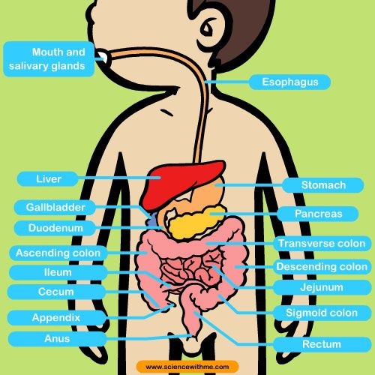

And you can bet that water is the main ingredient in perspiration, also called sweat. This helps to cool our bodies when we get too hot.

Besides being an important part of the fluids in your body, water is needed by each cell to function normally.

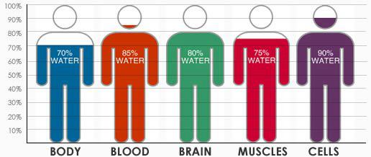
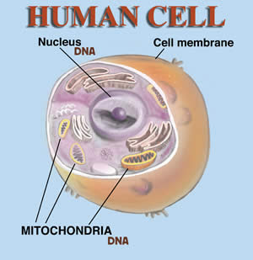
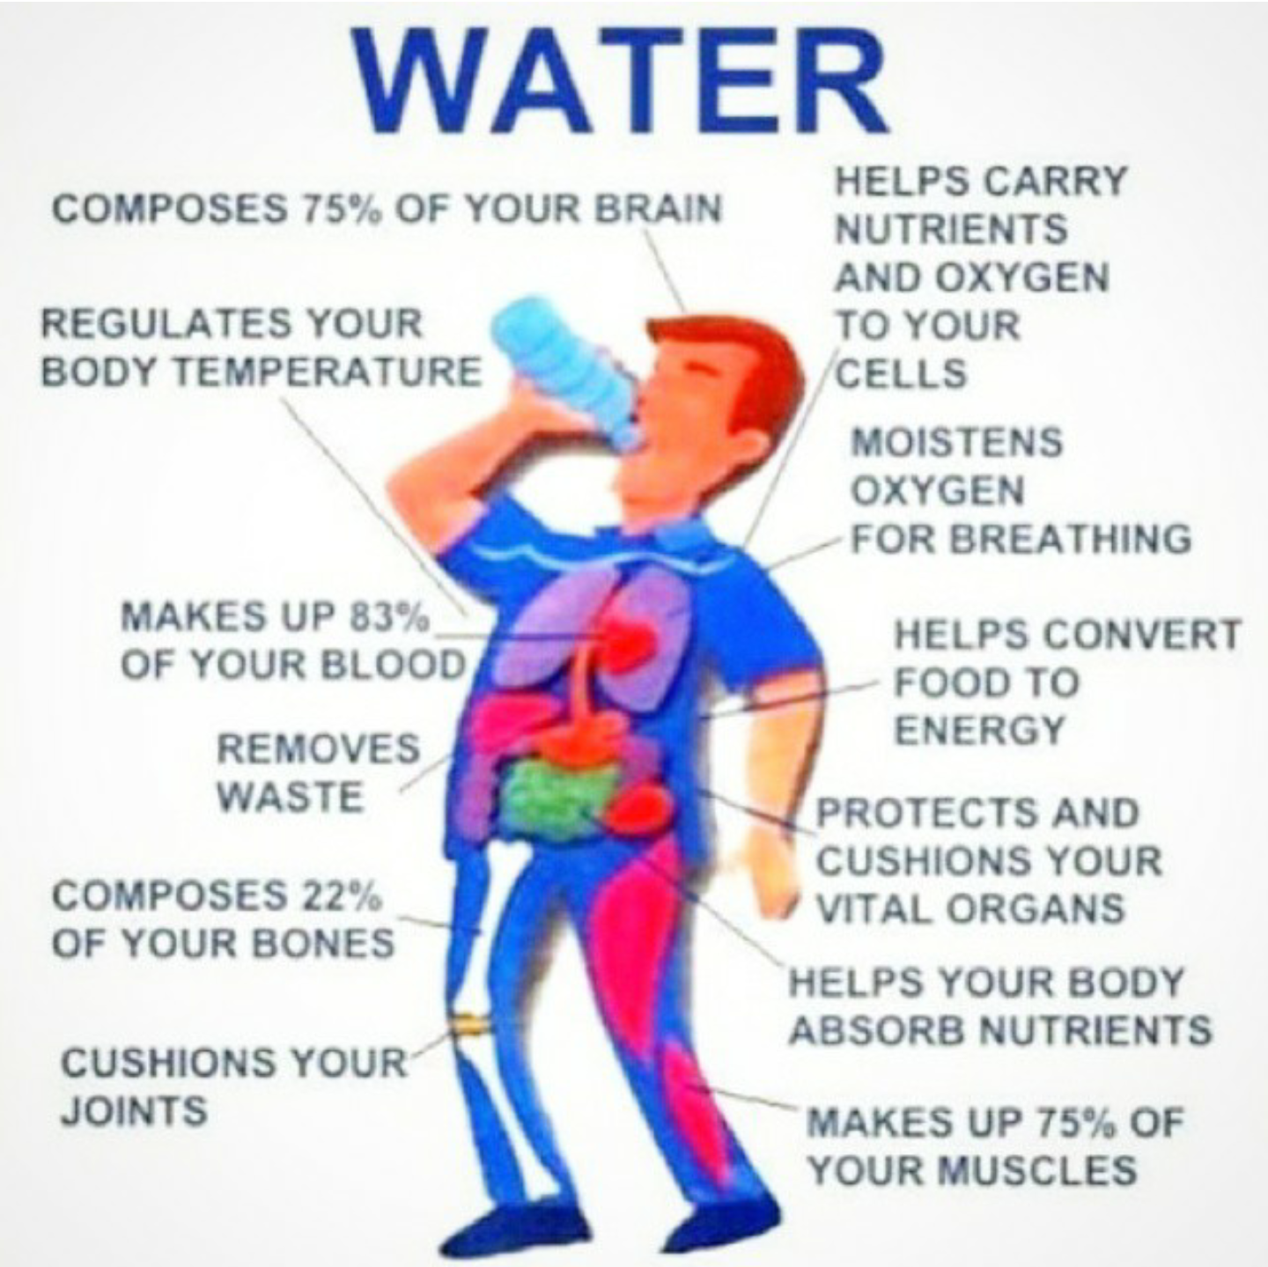

Your body doesn't get water only from drinking water. Any fluid you drink will contain water, but water is the best choice. Lots of foods contain water, too. Fruit contains quite a bit of water, which you could probably tell if you've ever bitten into a peach or plum and felt the juices dripping down your chin! Vegetables, too, contain a lot of water — think of slicing into a fat tomato from the garden or crunching into a crisp stalk of celery.
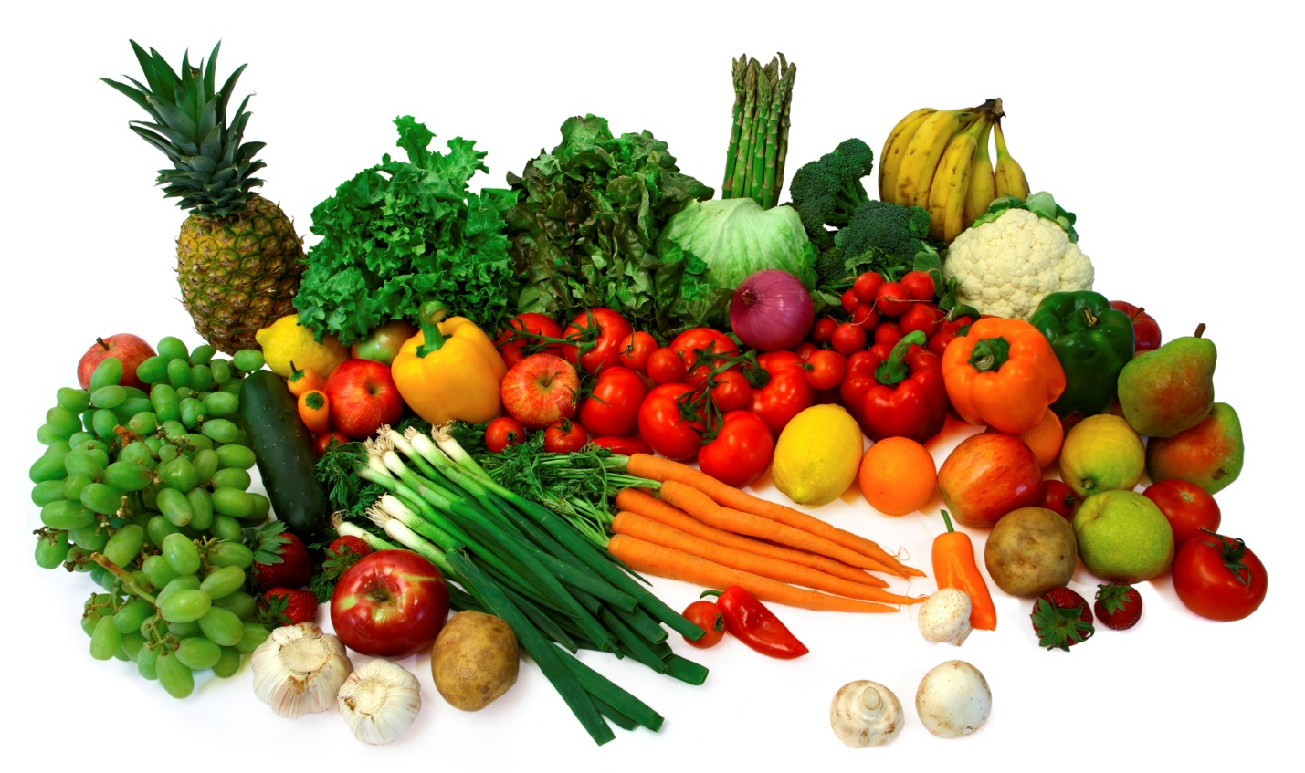

How Much Is Enough?
Since water is so important, you might wonder if you're drinking enough. Doctors recommend that children drink 6 cups and adults drink at least 8 cups of water a day. Be sure to drink some extra water when you're out in warm weather, especially while playing sports or exercising.
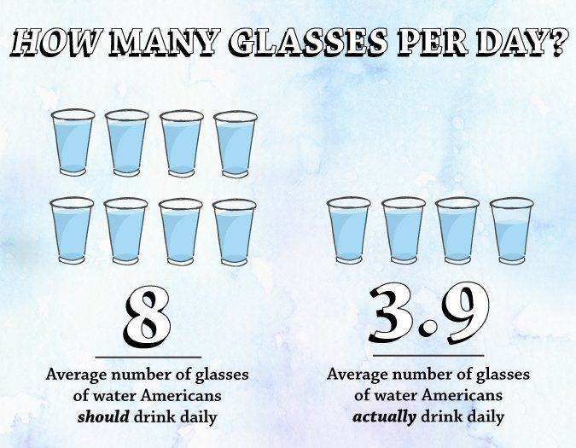

Your body can hold on to water when you don't have enough or get rid of it if you have too much. If your pee has ever been very light yellow, your body might have been getting rid of excess water. When your pee is very dark yellow, it's holding on to water, so it's probably time to drink up.

