THE EARTH AS AN APPLE 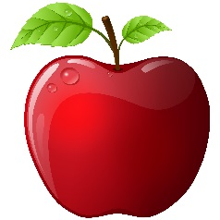
Pretend like this apple is planet earth.
- Slice the apple into quarters. 3 represent the water of the world. This leaves one slice which represents the land.

- Slice the remaining quarter land piece in half making two 1/8 pieces. Take one piece and tell the students that this piece represents areas that are either covered in snow and ice, or all sand (deserts), swamps or high/rocky mountains. That leaves this piece which is suitable for people to live.

- Slice the remaining 1/8 piece into 4 pieces giving you four 1/32nd pieces. Set aside 3 of these pieces. These 3 pieces are areas are too rocky, wet, cold, steep or the soil is too poor to actually produce food; or the land has already been used to build highways, houses, stores and other buildings.

- That leaves one 1/32nd slice which represents the land on earth that is suitable to grow plants and trees for food, for clothing (cotton), for shelter (timber) and for industrial raw materials like rubber, bean oils, corn for ethanol, etc.

- Carefully peel this slice. This tiny bit of peeling represents the very skin of the earth’s crust. The soil is 5 feet deep and this is what all the land animals and humans depend on to grow their food.
That is why it is so important to protect our soil.

