lpollen and carry it as t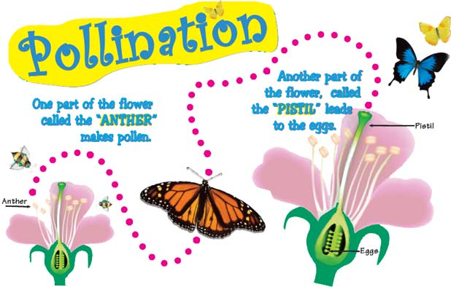hey fly back to their hive.

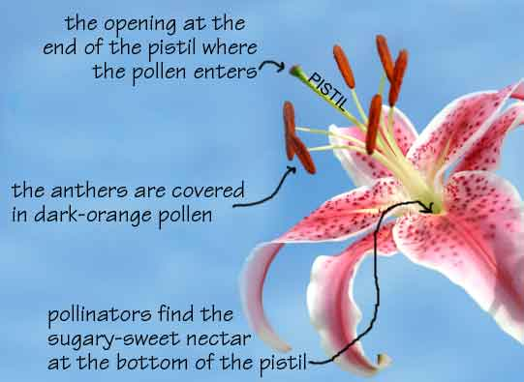

POLLINATOR PROGRAM
Materials: Green bag labelled pollinators located on first set of shelves on left in storage aisle. Bat masks and cootie catchers are on same shelf with green bag.
Teaching:
HI, MY NAME IS ____________ AND I WORK AT THE PETER FRANCISCO SOIL AND WATER CONSERVATION DISTRICT. WE HELP PEOPLE IN BUCKINGHAM AND CUMBERLAND TAKE CARE OF SOIL AND WATER. TODAY WE ARE LEARNING ABOUT LOCAL HEROES.

WE ALL KNOW ABOUT SUPER HEROES BECAUSE WE SEE THEM ON TV—BATMAN, SUPERMAN, IRONMAN, SPIDERMAN. THEY ARE NOT REAL, ARE THEY?

WHO ARE SOME OF OUR REAL LOCAL HEROES? (POLICE OFFICERS, FIREFIGHTERS, EMERGENCY MEDICAL TECHNICIANS, TEACHERS)

DID YOU EVER THINK OF BATS, BEES, BUTTERFLIES, HUMMINGBIRDS AND MOTHS BEING HEROES? DID YOU KNOW THAT A FLY IS A HERO TOO?

WHAT DO ALL OF THESE CRITTERS HAVE IN COMMON? THEY ARE ALL POLLINATORS.

JUST LIKE MAKING NEW PEOPLE OR NEW ANIMALS, PLANTS NEED A MALE AND FEMALE PART TO MAKE A NEW SEED WHICH WILL GROW INTO A NEW PLANT. THE DIFFERENCE WITH PLANTS IS THAT THEY HAVE BOTH THE MALE AND FEMALE PARTS EITHER IN A SINGLE FLOWER (A PERFECT FLOWER) OR ONE FLOWER HAS THE MALE PART AND ANOTHER FLOWER HAS A FEMALE PART (IMPERFECT FLOWER).

POLLEN IS MADE IN THE MALE PART CALLED THE STAMEN. THE STAMEN HAS 2 PARTS: A LONG FILAMENT WITH THE ANTHER ON TOP. POLLEN GRAINS ARE RELEASED BY THE ANTHERS. POLLEN LOOKS LIKE POWDER OR DUST. THE FEMALE PART OF THE FLOWER IS CALLED THE PISTIL. THE PISTIL MAKES THE EGG. IT HAS AN OPENING ON THE END WHICH IS STICKY SO IT CAN TRAP POLLEN. THE WAY THAT THE POLLEN FROM THE MALE PART FINDS ITS WAY TO THE FEMAL PART AND TRAVELS DOWN TO FERTILIZE THE EGG IS CALLED POLLINATION.
THE CREATURES WHO HELP MAKE THIS HAPPEN ARE CALLED POLLINATORS.
OVER 150 FOOD CROPS IN THE UNITED STATES DEPEND ON POLLINATORS. THINGS LIKE APPLES, ALFALFA, ALMONDS, BLUEBERRIES, CRANBERRIES, KIWIS, MELLONS, PEARS, PLUMS, SQUASH AND STRAWBERRIES DEPEND ON POLLINATORS. IN FACT, YOU CAN THANK YOUR LOCAL HERO, THE POLLINATOR, FOR ABOUT 1 OUT OF EVERY 3 BITES OF FOOD YOU EAT.
THESE ARE SOME FOODS THAT WE HAVE THANKS TO POLLINATORS. HOW MANY OF YOU LIKE CHOCOLATE? WELL, YOU CAN THANK A TINY-TWO WINGED FLY CALLED A MIDGE FOR POLLINATING THE CACAO (Ka cow) FLOWERS THAT MAKE THE COCOA BEANS THAT WE USE FOR CHOCOLATE. WHAT ABOUT CHEESE? WE ALL KNOW THAT CHEESE COMES FROM MILK AND MOST OF OUR MILK COMES FROM COWS. BUT, WHAT DO COWS EAT? THEY EAT ALFALFA GRASS WHICH BEES POLLINATE. SO YOU ENJOY BEEF AND CHEESE BECAUSE YOUR LOCAL HERO, THE POLLINATOR, HELPED THE ALFALFA GROW.
(RICE, CORN AND WHEAT ARE CROPS THAT ARE SELF-POLLINATED OR WIND-POLLINATED.)
MORE THAN 200,000 ANIMAL SPECIES SERVE AS POLLINATORS. 199,000 ARE TYPE OF INSECTS, ONLY ABOUT 1,000 ARE TYPES OF HUMMINGBIRDS, BATS OR OTHER SMALL MAMMALS.
LET’S WATCH A SHORT VIDEO AND SEE HOW POLLINATORS WORK.

(VIEW VIDEO FROM YOUTUBE Ted Talk - THE BEAUTY OF POLLINATION—link below) https://video.search.yahoo.com/search/video?fr=mcafee&p=the+beauty+of+pollination+ted+talk#id=6&vid=8ce6d94b7b49c30c100e9c095cd75c06&action=view

Additional Activities:
- OBSERVE FLOWERS WITH POLLEN WITH MAGNIFYING GLASS.
- PUT M&M’s in a Ziploc bag with ¼ cup of flour. M&M’s are the nectar and flour is the pollen. Have children pretend like they are a bee and they are going to a flower to get nectar (the flower is the Ziploc bag). In order to get the M&M (nectar) students will get flour (pollen) all over their fingers.
- MAKE MASKS or FOLD COOTIE CATCHER depending on age
- LET CHILDREN READ ABOUT LOCAL POLLINATORS FROM LAMINATED SHEETS
- Let students play with pollinator life cycle figurines and pollinator puppets. (purchased from Acorn Naturalist)

