ROCKS AND MINERALS

Today we are going to talk about rocks and minerals. We’ll start off by playing a game. You all have heard of the water cycle, right? Did you know there is such a thing as a rock cycle? (Or can play game after teaching).
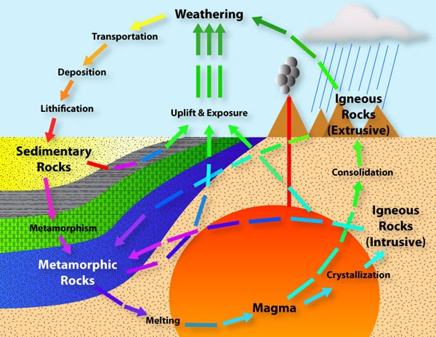
(Go over “Ride the Rock Cycle game rules)
Set up 11 stations with its designated die and tray of beads. Pass out the Journey sheet, a pencil and a bracelet string. Divide students equally among each station. Tell the students there are 11 stations and at each station is a die. You are now rocks and must roll your die at each station to determine which station you go to next. When you arrive at a station grab a bead for your bracelet. If you roll the die and it says to stay, write the name of the station again on your journey sheet and go to the back of the line until it is your turn to roll again. We will do this for 15 minutes.

Geology is the study of the solid earth of which rocks and minerals play a huge role. Rocks are made up of different types of minerals. So we will take a look at rocks first and identify some of the minerals in them before studying minerals and identifying a mineral for ourselves.
There are 3 types of rocks:
- Igneous 2. Sedimentary 3. Metamorphic
IGNEOUS
Igneous comes from the Latin word for fire (we use the Latin root for our word ignite). These rocks form from lava and magma. Does anyone know the difference between lava and magma?
- Lava is the molten or fluid rock that is expelled from a volcano. Lava forms extrusive rocks (think exit). The lava cools very quickly causing the minerals to be barely visible or not visible at all.
- Magma is molten or fluid rock that stays beneath the earth’s surface. Magma forms intrusive rocks (hear the word “In”). Magma cools much slower allowing the minerals which form plenty of time to grow resulting in a coarse-textured rock in which individual mineral grains are easily visible. .
Think of it like this: you are making chocolate chip/ M&M cookies. If you bake in a conventional oven and it cools slowly, you can still see the individual chocolate chips and M&M’s. If you nuke it in the microwave and it cools quickly, all the ingredients blend together and you can no longer see the chocolate chips or M&M’s.
- Some samples of extrusive igneous rocks are: obsidian (#12), Pumice (#14) scoria (#15) and basalt (#8). Has anyone ever used pumice to grind off the dead skin from your feet? Scoria used to be the lava rock placed in the bottom of gas grills. Most of the ocean floor is basalt (#6) (it has the word salt in it, so think salt water/ocean).
- A sample of intrusive igneous rocks: granite (#2) which by the way is the most common igneous rock in our continental crust—“Don’t take it for granted!” So the two most common rocks that make up the earth’s crust are igneous rocks: basalt (ocean floor) and granite (continental crust).

Take a look at these two famous carvings. Can you guess what type of rock they are carved from?
Mt. Rushmore near Rapid City, South Dakota. The rock is granite. Presidents are George Washington, Thomas Jefferson, Theodore Roosevelt and Abraham Lincoln.

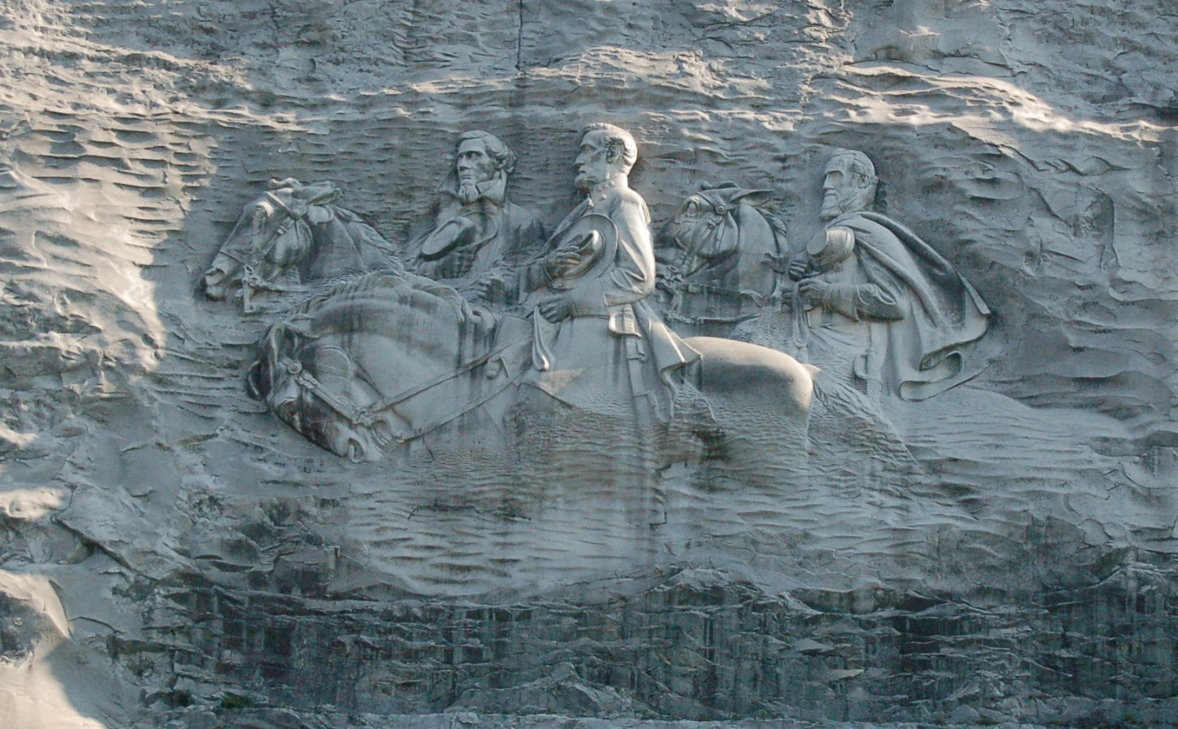
The largest exposed granite face in the world is Stone Mountain, 15 miles east of Atlanta, Georgia. Confederate figures from Civil War: Stonewall Jackson, Robert E. Lee and Jefferson Davis. FYI - This was actually carved before Mt. Rushmore.

Common minerals which make up granite are quartz, feldspar and mica (show samples). Granite is used for countertops, carvings, monuments, gravestones.
#5 Quartz
#2 Feldspar
#12 Mica

SEDIMENTARY
Sedimentary Rocks are formed from the “sediments” of other rocks through the process of erosion, followed by compaction or chemical precipitation. Sediments are classified by size—sand, silt and clay—with sand being the largest sediment and clay being the smallest sediment. Sand, silt and clay can be compared to salt, sugar and flour in their texture and particle size. Take a look at this sedimentary rock called sandstone (3). You can feel the sand. Siltstone (#28) is made up of silt-sized particles. Shale (#5) is made up of clay-sized particles. Feel how smooth it is.
Sedimentary rocks are grouped into two categories:
- Clastic – formed by mechanical weathering. What causes the earth’s surface to wear down or weather? Wind, rain, freezing and thawing, animals and people walking on it. This weathering process produces gravels, sands and silts that are cemented together (show conglomerate #S-1 and sandstone #S-3)
Non-clastic – Not made from sediments

  - Organic – example #15 bituminous coal made from dead plants
  - Inorganic – also known as chemical rocks made from precipitates or evaporation of water with chemicals that leaves behind a rock, like limestone.

- The most famous chemical rock formations are stalactites and stalagmites like you see in caverns. They are made from limestone (show #S-8).
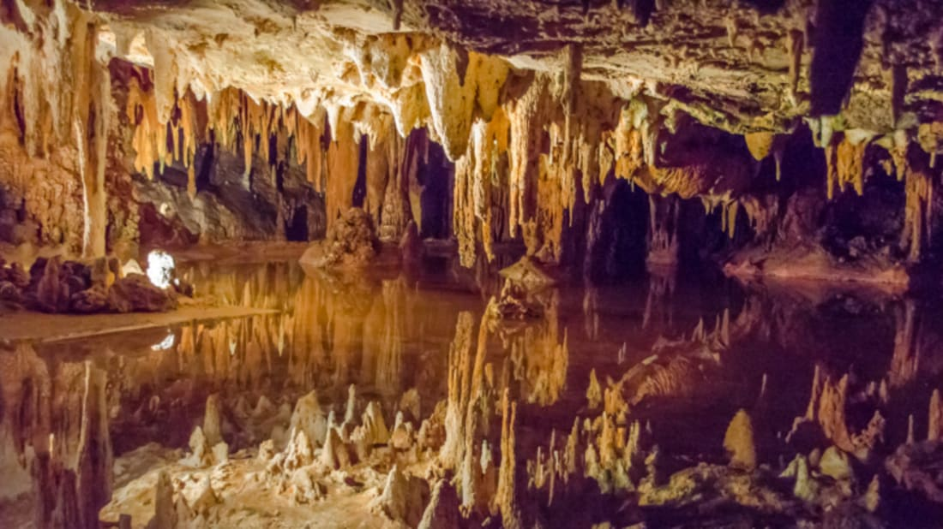
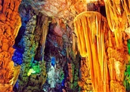
Do you know the difference between a stalactite and a stalagmite? Stallactite has a “c” in it so think ceiling and it also has the word tight in it so think hold tight to the ceiling. Stalagmite has a “g” in it, so think ground and the word “might” in it—I might grow up! Rock salt is another chemical rock (#S-13). If you licked this, it tastes like salt because that is what it is!
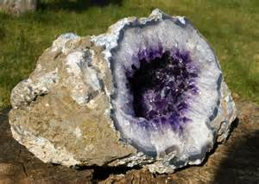A geode is a sedimentary rock that gets a hole in it. Water containing minerals flows through the hole. The water evaporates leaving behind the minerals in the middle of the sedimentary rock. Not only can we say you can’t judge a book by its cover, or people by the way they look on the outside--we can say we can’t judge a rock by its exterior!
METAMORPHIC
The third type of rock is metamorphic. These are igneous and sedimentary rocks that have changed or are recrystallized in the solid state by pressure and/or heat. The change may be partial so that some of the original characteristics are kept or it may be so complete that new minerals are formed and the texture is changed. These rocks are very dense rocks. A ping pong ball and a golf ball are about the same size, but the golf ball is much denser than a ping pong ball and therefore weighs a whole lot more.
(Pass around golf ball and ping pong ball).
There are 2 types of metamorphic rocks:
- Foliated like this piece of gneiss (#M-1) where you can see the layers of the rock that formed the former rock almost melts back to a liquid state and the minerals are rearranged into layers at it recrystallizes.
- Non-foliated like this piece of marble (#M- 12) where you cannot see any layers.
The metamorphic rock gneiss (#M-1) used to be the igneous rock granite (#2), but heat and pressure changed it to a denser rock.
- New York City’s bedrock is made of up 3 strata or layers of metamorphic rocks—schist (#M-3), marble (#M-12) and gneiss (#M-1). This gives a firm foundation for the tall skyscrapers.
- If you take a walk around Holliday Lake, you can find garnet schist (#M-4). You can actually see small garnets in this rock. Garnets are a semi-precious gem, but the garnets in this rock are not worth anything since they have been heated too long (kind of like burning a cookie). Diamonds, rubies, emeralds, and sapphires are some examples of precious gems.
- What is a metamorphic rock that Buckingham is famous for? I’ll give you a hint: you can use it for a chalkboard or for a roof or for a walkway. We also use small pieces of this for our driveways. Show #M-6 slate and #S-6 shale. Slate used to be the sedimentary rock shale. The sedimentary rock gypsum (#S-9) is sort of like chalk. Let’s write with it on the slate. All you hunters out there: what else is slate used for? Use wood to rub against it and you have yourself a turkey call.
- Marble (#S-12) used to be the sedimentary rock limestone (#S-8). Marble is used for statues, trophy bases, countertops, tombstones. Limestone used to be used for gravestones because it is easy to engrave, but rain with acid in it washes the limestone away. So if you look at old gravestones and can’t make out the name or the year they died, the gravestone is probably made out of limestone. With heat and pressure, the limestone is more dense and is harder to dissolve. Both limestone and marble are made from calcium carbonate (CaCo3). Acid breaks down calcium carbonate. If you had hydrochloric acid and diluted it to 1 drop acid to 99 drops of water, you could put a drop on marble or limestone and watch it fizz.
- Soapstone was used to line fireplaces. Sheets of it were put over top of brick and rock because it holds heat real well. Soapstone was the mineral talc (#19 from Classroom Collection) Ever heard of talcum powder also known as baby powder?

MINERALS
Now we move to minerals. Geologists have identified about 5,000 different minerals. They are the building blocks of rocks. There are 5 conditions that must be met to be a mineral:
- Has to be naturally occurring (not manmade like plastic)
- Has to be inorganic (not living)
- Has to be solid (not liquid or gas)
- Has to have a definite crystal structure which means the atoms are always arranged the same for each mineral. (quartz always has 6 sided crystal)
- Has to have fixed chemical formula—a specific recipe of elements. Qaurtz is made of silicone and oxygen SiO₂. Pyrite aka (fool’s gold) Iron and Sulfur FeS₂
Your body needs vitamins and minerals to function properly. Most people get the amount of minerals by eating a wide variety of foods, but sometimes it is necessary to take a mineral supplement. Whereas vitamins are organic substances made by plants or animals, minerals are inorganic elements that come from the soil and water and are absorbed by plants or eaten by animals.
Your body uses minerals for many different jobs, including keeping your bones, muscles, heart and brain working properly. Minerals are also important for making enzymes and hormones.
There are 2 kinds of minerals: macrominerals and trace minerals. You need larger amounts of macrominerals. They include calcium, phosphorus, magnesium, sodium, potassium, chloride and sulfur. You only need small amounts of trace minerals. They include iron, manganese, copper, iodine, zinc, cobalt, fluoride and selenium.

Next we will talk about some minerals that may be of real interest to you: gemstones and precious metals.

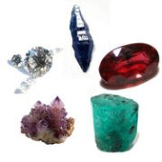
WHAT ARE GEMSTONES?
Gemstones are crystalline minerals that can be cut and polished to make jewelry and other ornaments. The ancient Greeks made a distinction between precious and semiprecious gems, which is still used. Precious stones were hard, rare, and valuable. The only "precious" gemstones are diamond, ruby, sapphire, and emerald. All other quality stones are called "semiprecious," even though they may not be any less valuable or beautiful. Today, mineralogists and gemologists describe stones in technical terms, including their chemical composition, Mohs hardness, and crystal structure.

The mineral beryl is where the gems emeralds and aquamarines come from

Chorundum – if it is blue = sapphire red = ruby

INTERESTING FACT: A pearl is not a gemstone or mineral. It is made from sand which irritates the oyster causing it to secrete layer after layer of protection. Pearls are organic. Remember that minerals have to be inorganic.

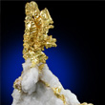 THE MINERAL GOLD

Gold – Gold is the most precious metal. It very dense but soft. Have you ever seen people bite gold to see if it is real? If it is real your teeth will leave an impression. If it is fool’s gold (pyrite) you’ll break your tooth which would be foolish. If you want to save your teeth, use a streak plate. Gold leaves a gold streak. Pyrite leaves a black streak.

Gold is one of the most popular and well-known minerals, known for its value and special properties since the earliest of time. Gold in its natural mineral form almost always has traces of silver, and may also contain traces of copper and iron. A Gold nugget is usually 70 to 95 percent gold, and the remainder mostly silver. The color of pure Gold is bright golden yellow, but the greater the silver content, the whiter its color is. Much of the gold mined is actually from gold ore rather than actual Gold specimens. The ore is often brown, iron-stained rock or massive white Quartz, and usually contains very small traces of gold. To extract the gold, the ore is crushed, then the gold is separated from the ore by various methods.
Gold nuggets, a popular form of Gold with collectors, are formed when erosion causes a large piece of Gold to separate from its mother rock, and then gets carried into a stream or river. The flowing water tumbles the Gold, giving it its distinct rounded shape. The Gold eventually settles at the bottom of the water, and due to its heaviness remains there. Gold is one of the heaviest minerals. When pure, it has a specific gravity of 19.3. Due to its weight, it can be panned because the Gold sinks to the bottom. In addition, it can be easily separated from other substances due to the weight differences. Gold is also the most malleable and ductile substance known. It can be flattened out to less than .00001 of an inch and a 1 oz. mass can stretch out to a distance of over 50 miles. Gold is also one of the most resistant metals. It won't tarnish, discolor, crumble, or be affected by most solvents. This adds on to the uniqueness and allure of this mineral.

Copper was one of the first metals ever extracted and used by humans, and it has made vital contributions to sustaining and improving society since the dawn of civilization. Copper was first used in coins and ornaments. Copper tools helped civilization emerge from the Stone Age. The discovery that copper alloyed with tin produces bronze marked the beginning of the Bronze Age. The U.S. penny was made of pure copper from 1783 to 1837. From 1837 to 1857 it was made from bronze (96% copper and 5% tin and zinc). From 1857 to 1864, our penny was made from 88% copper and 12% nickel. From 1864 to 1962 our penny was bronze with the exception of the year 1943. Copper was desperately needed for the war effort, so pennies were made of zinc-coated steel. From 1962 to present, our penny is made of copper-coated zinc. Copper is easily stretched, molded, and shaped; is resistant to corrosion; and conducts heat and electricity efficiently. As a result, copper was important to early humans and continues to be a material of choice for a variety of domestic, industrial, and high-technology applications today.
Presently, copper is used in building construction, power generation and transmission, electronic product manufacturing, and the production of industrial machinery and transportation vehicles. Copper wiring and plumbing are integral to the appliances, heating and cooling systems, and telecommunications links used every day in homes and businesses. Copper is an essential component in the motors, wiring, radiators, connectors, brakes, and bearings used in cars and trucks. The average car contains 1.5 kilometers (0.9 mile) of copper wire, and the total amount of copper ranges from 20 kilograms (44 pounds) in small cars to 45 kilograms (99 pounds) in luxury and hybrid vehicles.

Other interesting mineral facts:
- Quartz is the most common mineral found in the earth’s crust. It is found in all types of rocks: Igneous, Sedimentary and Metamorphic and comes in all different colors. Weather erosion causes it to break into sediment. The particle size of quartz sediment is sand. Sand is melted down to become glass.

- The mineral Feldspar breaks down to clay size particles. Red slate, quartz and feldspar sediments primarily make up the soil in the Buckingham and Cumberland County area.

- The mineral Galena is where we get lead for fishing weights and shotgun pellets. It has a perfect box cube crystal form

- The mineral Graphite = pencil lead

- Diamonds have only been found in one state in the U.S. – Arkansas

- The mineral Bauxite is aluminum

- The mineral Sulphur can smell like rotten eggs

- The mineral gypsum is used in building. Drywall is made of it because it is fire retardant (slows fire).
- Mineral fluorite is used to make fluoride toothpaste.

Buckingam County is famous for a mineral found in Willis Mountain which helped make the Dixon family quite wealthy. Does anybody know what it is? Kyanite! Do any of your relatives work for Kyanite Mining Corporation?
Kyanite has a long bladed or needle-like crystal which is softer than a knife blade along the length of the crystal but much harder than a knife blade across the crystal. Its color is usally blue but may be white, gray or green.
Why is kyanite important? It is used in the manufacture of refractories. A refractory is material that can withstand extremely high temperatures without breaking down or softening (3,000 degrees Celsius or 5,432 degrees Fahrenheit). Refractory materials are used in certain ceramics and superalloys, in heat insulation for furnaces, jet and rocket engines and space vehicles.

In Buckingham, kyanite is found in a metamorphic rock called quartzite. Quartzite forms which quart-rich sandstone or chert has been exposed to high temperatures and pressures fusing the quartz grains together to form a dense, hard equigranular rock.

Kyanite Mining Corporation quarries the quartzite from open pits. It is processed by primary crushers, passed through a log washer to wash off the clay then moved onto classifiers to remove some kyanite. The remaining material passes through a rod mill which reduces it to a minus 35-mesh size. This material moves through froth flotation cells so the remaining kyanite can be skimmed off. It is dried with high temperatures which converts the sulfide minerals to oxides. Iron and pyrite are converted to magnetite which is removed by magnetic separators and stockpiled.

IDENTIFYING MINERALS
There are several tests that we can perform to identify a mineral. Let’s break up into groups of 2 or 3. I’ll give you a test kit, and a mineral, physical property chart and worksheet. We will go over each test together so you can identify your mineral.

Bottom of Form

Top of Form
Bottom of Form

Step 1: Pick Your Mineral
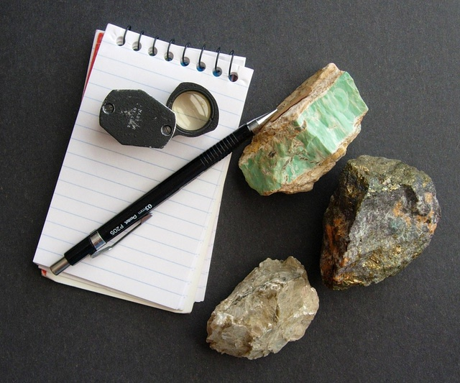
Learning mineral identification is like learning to cook. You begin by following step-by-step procedures and looking up a lot of things. But after a while you notice regularities, become familiar with the usual suspects, make some productive mistakes, and get better at it until it becomes easy and fun.
Another way mineral identification is like cooking is that professionals can go to school, learn to use expensive equipment and master the subject fully, yet amateurs can handle nearly all the common possibilities using just a few simple tools.

Step 2: Color
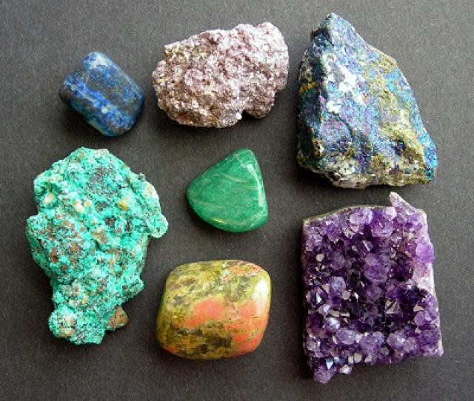
Beware of color until you've learned what colors to trust. Photo Credit: Photo (c) 2011 Andrew Alden, licensed to About.com (fair use policy)
Color is important in mineral identification, but it can be a complicated subject. Experts use color all the time because they have learned the usual colors and the usual exceptions for common minerals. If you're a beginner, pay close attention to color but do not rely on it. First of all, be sure you aren't looking at a weathered or tarnished surface, and examine your specimen in good light. Color is a fairly reliable indicator in the opaque and metallic minerals—for instance the blue of the opaque mineral lazurite or the brass-yellow of the metallic mineral pyrite. In the translucent or transparent minerals, color is usually the result of a chemical impurity and should not be the only thing you use. For instance, pure quartz is clear or white, but quartz can have many other colors.
Try to be precise with color. Is it a pale or deep shade? Does it resemble the color of another common object, like bricks or blueberries? Is it even or mottled? Is there one pure color or a range of shades? If you have an ultraviolet light, this is the time to see if the mineral has a fluorescent color. Make note if it displays any other special optical effects.

Step 3: Luster
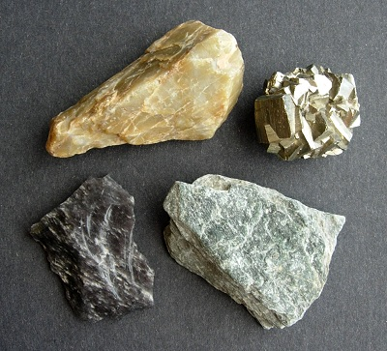
Many minerals have distinctive lusters—get to know them. Photo Credit: Photo (c) 2011 Andrew Alden, licensed to About.com (fair use policy)
Luster is the way a mineral reflects light and the first key step in mineral identification. Look for luster on a fresh surface. The three major types of luster are metallic, glassy (vitreous) and dull. A luster between metallic and glassy is called adamantine, and a luster between glassy and dull is called resinous or waxy.

Step 4: Streak
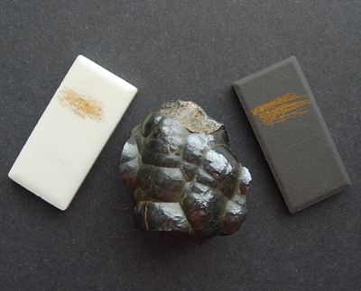
Streak is an easy test that's sometimes definitive. Photo Credit: Photo (c) 2011 Andrew Alden, licensed to About.com (fair use policy)
Streak is the color of the finely crushed mineral. Streak is somewhat more reliable than color and is essential for a few minerals. You'll need a streak plate or something like it. A broken kitchen tile or even a handy sidewalk can do. Scratch your mineral across the streak plate with a scribbling motion.

Step 5: Hardness
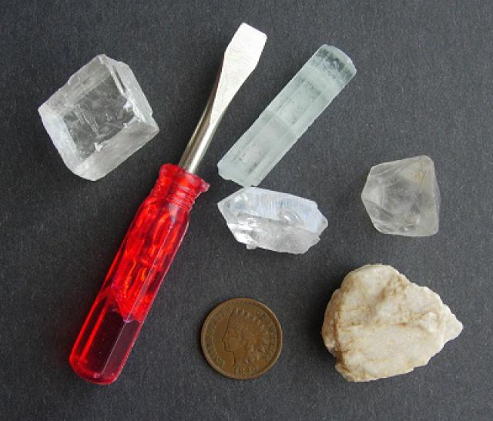
The Mohs scale is low-tech but time-tested. Photo Credit: Photo (c) 2011 Andrew Alden, licensed to About.com (fair use policy)
When we say hardness, what are we talking about? What do you think is harder—a hammer or a piece of glass? The piece of glass is actually harder. Hardness is a difficult concept. It is not about breaking, bashing, smashing, or pulverizing. It is about scratch. The hammer cannot scratch the glass, but the glass can scratch the hammer. Geologists use the 10-point Mohs hardness scale with 1 (talc) being the softest and 10 (diamond) being the hardest. The glass has a hardness on the Mohs scale of 6.5 while the aluminum on the hammer has a hardness of 3.4. To determine hardness you'll need your fingernail (hardness about 2), a penny (hardness 3), a nail (hardness 5.5) and a glass plate (6.5). The streak plate you used earlier is porcelain and has a hardness of 7.0
Mohs hardness | Mineral | Chemical formula | Absolute hardness^{[11]} | Image
1 | Talc | Mg₃Si₄O₁₀(OH)₂ | 1 | 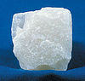
2 | Gypsum | CaSO₄·2H₂O | 3 | 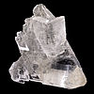
3 | Calcite | CaCO₃ | 9 | 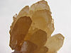
4 | Fluorite | CaF₂ | 21 | 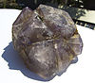
5 | Apatite | Ca₅(PO₄)₃(OH⁻,Cl⁻,F⁻) | 48 | 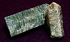
6 | Orthoclase feldspar | KAlSi₃O₈ | 72 | 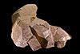
7 | Quartz | SiO₂ | 100 | 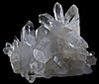
8 | Topaz | Al₂SiO₄(OH⁻,F⁻)₂ | 200 | 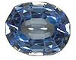
9 | Corundum | Al₂O₃ | 400 | 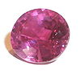
10 | Diamond | C | 1600 | 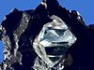

Step 6: Crystal Form and Mineral Habit
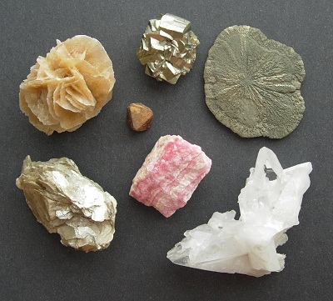
Crystal form requires study; mineral habit, not so much. Photo Credit: Photo (c) 2011 Andrew Alden, licensed to About.com (fair use policy)
A good knowledge of crystals is very helpful once you're past the beginner stage, but often minerals do not display any crystal faces, so for simplicity's sake we'll ignore it. For beginners, a mineral's crystal form is less important than its cleavage (see the next step). When you're ready to learn this aspect of minerals, you'll want a book.
One thing even beginners can do, though, is to observe a mineral's habit, the general form it takes.
There are more than 20 different terms describing habit—see most of them illustrated in the Mineral Habits Gallery.

Step 7: Cleavage and Fracture
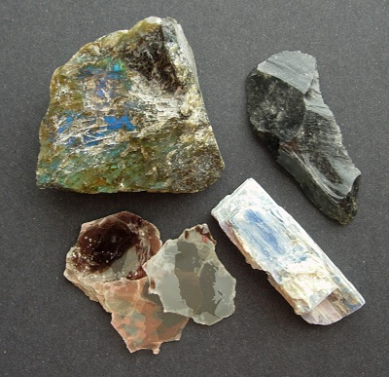
How minerals break is a key clue to their identification. Photo Credit: Photo (c) 2011 Andrew Alden, licensed to About.com (fair use policy)
Cleavage is the way a mineral breaks. Many minerals break along flat planes, or cleavages—some in only one direction (like mica), others in two directions (like feldspar), and some in three directions (like calcite) or more (like fluorite). Some minerals, like quartz, have no cleavage. Cleavage is a profound property that results from a mineral's molecular structure, and cleavage is present even when the mineral doesn't form good crystals. Cleavage can also be described as perfect, good or poor.
Fracture is breakage that is not flat. The two main kinds of fracture are conchoidal (shell-shaped, as in quartz) and uneven. Metallic minerals may have a hackly (jagged) fracture. A mineral may have good cleavage in one or two directions but fracture in another direction.
To determine cleavage and fracture, you'll need a rock hammer and a safe place to use it on minerals. A magnifier is also handy, but not required. Carefully break the mineral and observe the shapes and angles of the pieces. It may break in sheets (one cleavage), splinters or prisms (two cleavages), cubes or rhombs (three cleavages) or something else.
Step 8: Magnetism
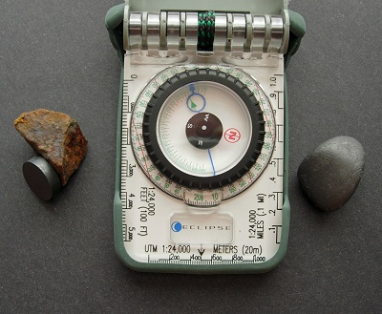
Always test for magnetism with a dark mineral—it's not hard. Photo Credit: Photo (c) 2011 Andrew Alden, licensed to About.com (fair use policy)
Magnetism is a distinctive property in a few minerals. Magnetite is the prime example, but a few other minerals may be weakly attracted by a magnet, notably chromite (a black oxide) and pyrrhotite (a bronze sulfide). Use a strong magnet. The magnets I use came from the corners of an old plastic shower curtain. Another way to test magnetism is to see if the specimen attracts a compass needle.

Step 9: Other Mineral Properties
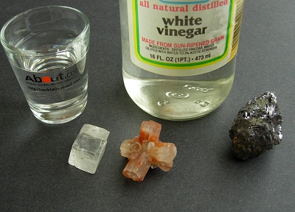
A few other tests may sometimes be exactly the right one for certain minerals. Photo Credit: Photo (c) 2011 Andrew Alden, licensed to About.com (fair use policy)
Taste is definitive for halite (rock salt), of course, but a few other evaporite minerals also have distinctive tastes. Just touch your tongue to a fresh face of the mineral and be ready to spit—after all it's called taste, not flavor. Don't worry about taste if you don't live in an area with these minerals.
Fizz means the effervescent reaction of certain carbonate minerals to the acid test. For this test, vinegar will do.
Heft is how heavy a mineral feels in the hand, an informal sense of density. Most minerals are about three times as dense as water, that is, they have a specific gravity of about 3. Make note of a mineral that is noticeably light or heavy for its size. Galena, on the right, is distinctly heavy. Sulfides and oxides tend to be dense.

